**ANTI RAGGING PORTAL”**

**PROJECT REPORT**

***Submitted by***

|  |  |
| --- | --- |
| Akash Saxena | * 1649210013 |
| Ritu Raj | * 1649210072 |
| Vinay Rana | * 1649210098 |
| Sunny Rana | * 1649213030 |
| Harshit Rastogi  Abhinav Pandey | * 1649210036 * 1649210005 |

***in partial fulfillment for the award of the degree***

***of***

**BACHELOR OF TECHNOLOGY**



KCC INSTITUTE OF TECHNOLOGY AND MANAGEMENT

GREATER NOIDA.

**OCTOBER - 2019**

#### *CERTIFICATE*

This is to certify that the Major Project report entitled “**ANTI RAGGING PORTAL**” submitted by **Akash Saxena, Ritu Raj, Vinay Rana, Sunny Rana, Harshit Rastogi, Abhinay Pandey** has been carried out under my guidance & supervision. The project report is approved for submission towards partial fulfillment of the requirement for the award of degree of **BACHELOR OF TECHNOLOGY** from “**KCC INSTITUTE OF TECHNOLOGY AND MANAGEMENT” .**

(Mr. Surya Sutapali) (Dr. Dolly Sharma)

Project Guide Head Of Department

**Computer Science and Information Technology.**

# 

#### *CERTIFICATE*

This is to certify that the Major Project report entitled “**ANTI RAGGING PORTAL**” is submitted by **Akash** **Saxena, Ritu Raj, Vinay Rana, Sunny Rana, Harshit Rastogi, Abhinav Pandey** for the partial fulfillment of the requirement for the award of degree of **BACHELOR OF COMPUTER SCEIENCE AND INFORMATION TECHNOLOGY** from “**KCC INSTITUTE OF TECHNOLOGY AND MANAGEMENT” Greater Noida.**

Mr. Om Prakash Mr. Akhilesh Kumar Soni

IPS(Centre Of Computer Education) Global Talent Track(GTT)

Internal Examiner External Examiner

Date : 30/04/2012 Date : 30/04/2012

# 

#### *DECLARATION*

We hereby declare that the project entitled **“ANTI RAGGING PORTAL”** which is being submitted in partial fulfillment of the requirement for award of the Degree of Bachelor of Computer Applications to **“BACHELOR OF TECHNOLOGY** from “**KCC INSTITUTE OF TECHNOLOGY AND MANAGEMENT”**  is an authentic record of our own work done under the guidance of **Mr. Surya Sutapali.**

The matter reported in this Project has not been submitted earlier for the award of any other degree.

**Dated : 17/10/2019 Akash Saxena**

Place : GREATER NOIDA Ritu Raj

Vinay Rana

Sunny Rana

**Harshit Rastogi**

**Abhinav Pandey**

#### *ACKNOWLEDGEMENT*

We sincerely express indebtedness to esteemed and revered guide “Mr. Surya Sutapali”, *Designation* in *Department name* for his invaluable guidance, supervision and encouragement throughout the work. Without his kind patronage and guidance the project would not have taken shape.

We take this opportunity to express deep sense of gratitude to “Dr. Dolly Sharma”, Head of “Computer Science And Information Technology , for his encouragement and kind approval. Also we thank him in providing the computer lab facility. We would like to express our sincere regards to him for advice and counseling from time to time.

**Dated : 17/10/2019** Akash Saxena

Place : Greater Noida Ritu Raj

Vinay Rana

Sunny Rana

**Harshit Rastogi**

**Abhinav Pandey**

**TABLE OF CONTENTS**

1.Introduction………………………………………………….…7-8

2.Problem Definition……………………………………………8-9

3.Requirements……………………………………………….9-13

4.Design……………………………………………………….13-18

5.Implemention……………………………………………...18-34

6.Application……………………………………………….34-38

7.Conclusion………………………………………………. 39 -42

References

Bibliography

1. **Introduction**

Ragging has become deeply rooted into the Indian educational set up, but ragging is originally western concept. Ragging is hypothetical to have its creation in European Universities where the seniors of the institution used to play practical jokes at the time of welcoming freshers to the institutions. Slowly, the exercise of ragging became fashionable all the way through the world. On the other hand, with time, ragging assumed loathsome and damaging connotations and was sternly condemned. Almost all the countries of the world have enacted strict laws that ban ragging and it has been completely eradicated in countries such as Canada and Japan. However sorrowfully, India, which inherited ragging as an inheritance from the British rule, has not been capable of freeing itself from the control of this inhumane practice. It can be said that the worst outline of ragging is committed in India. Ragging has become a key apprehension of today’s society. Ragging has amplified its intensity from colleges and universities to civilization level and has become a key apprehension of today’s society. Ragging in India is a destructive method of communication of the seniors in universities or schools with their juniors or fresher’s.

Objectives:-

1. The new students must register with the portal before availing any services from it.
2. For each registration, maintain the complaints record in the database for the new user.
3. To reduce the usage of paper and maintain the database and updating according to the needs is the key area of concern.
4. When the student wants to register complaint they can apply online using this application and later approved by the administrator.
5. Every user student has to register first to get the access first.
6. The administrator has the access of student’s complaints and feedbacks.
7. Students may review their complaint’s and feedback’s progress.
8. The online record provided by the portal may prove useful to the students.
9. Student’s complaint progress is seen step by step on the portal.

Analysis of existing System:-

Under the analysis model, we analyze the system to check the following:

1. Whether it meets the requirements that guided its design and development.
2. Works as expected.
3. Can be implemented with the same characteristics.

Limitations of the existing System:-

Limitations have been improved in the developed system of

Anti - Ragging Portal and it has more features to improve on these problems, providing a one step solution.

Reduce the paper use by providing the registration online.

1. **Problem Definition**

The Overall Description section, of this document gives an overview of the functionality of the product. It describes the informal requirements and is used to establish a context for the technical requirements specification in the next heading.

The Product system feature, Operating Environment, Design and Implementation Constraints, of this document is written primarily for the developers and describes the details of the functionality of the product. This system will be completely web-based and the remote web server from a standard web browser. An Internet connection is necessary to access the system.

The main purposes of this project are:-

* Portal will be dealing with the commonly found behavioral patterns with ragging in the light of some recent cases and their consequences.
* Different users have different functionalities on one common platform.
* New students can register and get updated in the databases.
* Administrator can keep track of students.

**Benefits of the Project:**

This system makes student comfortable and make work paperless. Benefits to each of these are described below.

**Benefit to Students:**

With availability of the students, this portal will provide the facility of providing complaint registration online. He or She is register securely by sitting in his home also.

1. **Requirements**

## External Interface Requirements

## User Interfaces

The user interface is screen shown on the browser. The Home screen of the Web-Portal is students and admin can register and login. The portal screen acts as an interface to provide services to the user which are to be availed from the database.

## Hardware Interfaces

**a**. Processor – Dual Core

**b.**  Hard Disk – 500 GB

**c.** Memory – 4 GB RAM

**d**. Mouse – Any Standard

**e.** Keyboard – Any Standard

**f.** Monitor – Any color monitor

**g**. Local Area Network Preferable

## Software Interface

The system uses:

* Windows/Unix/Linux
* MYSQL
* Eclipse
* Java-JEE environment.

1. **Communications Interfaces**

Internet connection and Browser are required in order for several functions to be executed such as downloading. The system uses the following browsers:-

## Mozilla Firefox

## Google Chrome

## Internet Explorer

**3.1 Technology used:**

Frontend is done by: HTML, CSS, Bootstrap, JavaScript.

Backend is done by: JAVA, JDBC, MYSQL

**3.2 Operating Environment**

***Programming languages***

* **JAVA EE**: Java Enterprise Edition is a programming platform— part of the Java Platform-for developing and running distributed multi-tier architecture Java applications, based largely on modular software components running on an application server.
* **HTML**: Hyper Text Markup is the predominant markup language for web pages. It provides a means to describe the structure of text-based information in a document and to supplement that text with interactive forms, embedded images, and other objects.
* **JavaScript**: A client side scripting language used to create dynamic web content and user interface

Tools & Development Environment

* **Apache Tomcat 8.5 Server**: Apache Tomcat is a Servlet container developed by the Apache Software Foundation (ASF). Tomcat implements the Java Servlet and the JavaServer Pages (JSP) specifications from Sun Microsystems, and provides a "pure Java" HTTP web server environment for Java code to run.

#### High-Level Requirements:

The following table presents the requirements that the project’s product, service or result must meet in order for the project objectives to be satisfied.

| Req. # | I Requirement Description |
| --- | --- |
| Registration | To Provide complete access to the users i.e.to become a valid user. |
| Login id | Every user have there login id to access the portal. |
| Password | Accessing the web details every user it can be  parent, administrator . |
| Network Connectivity | The user should have fast internet connection and should be  supported by an advanced browser. |
| Availability Of Online  Updated Information | Only valid members can have the access of the  update information. |
| Updated database | Every information which is updated in the profile should be updated in the database. |

#### 4. **Other Non-functional Requirements**

## a. Performance Requirements

Some Performance requirements identified is listed below

* 1. The database must be support more than 100 student, record.
  2. Can support many user at the same time.
  3. High speed internet.

## b. Safety Requirements

The material uploaded must be for the authentic user this can be provide by there-strict communications between some areas of the program (constraints). Material should be accessed by intended user.

## c. Security Requirements

Some of the factors that are identified to protect the software from accidental or malicious access, use, modification, destruction, or disclosure are described below. Specific requirements in this are could include the need to:

* + - 1. Keep specific log or history data sets.
      2. Check data integrity for critical variables.
      3. Communication needs to be restricted when the application is validating the user .
      4. Providing Authentication

**5.Design**

(It should be done in 2 stages- Architectural Design and Detailed Design. The Detail design should contain Database, ERD, Data Flow diagram etc**.)**

**4.1 Architectural D**

**4.1.1 Use case Diagram**

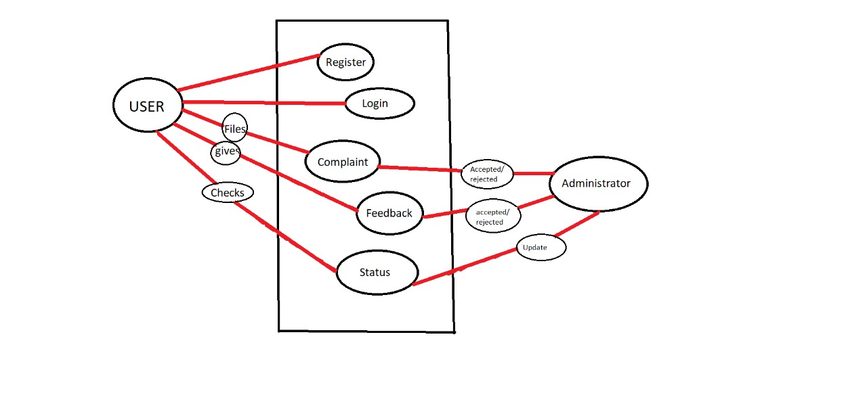

**4.2 Detailed Design**

**4.2.1 ER Diagram**

**1.** **ADMIN**

1.1 ADMIN accepts/rejects complaints and feedback and can also update status of the complaint.

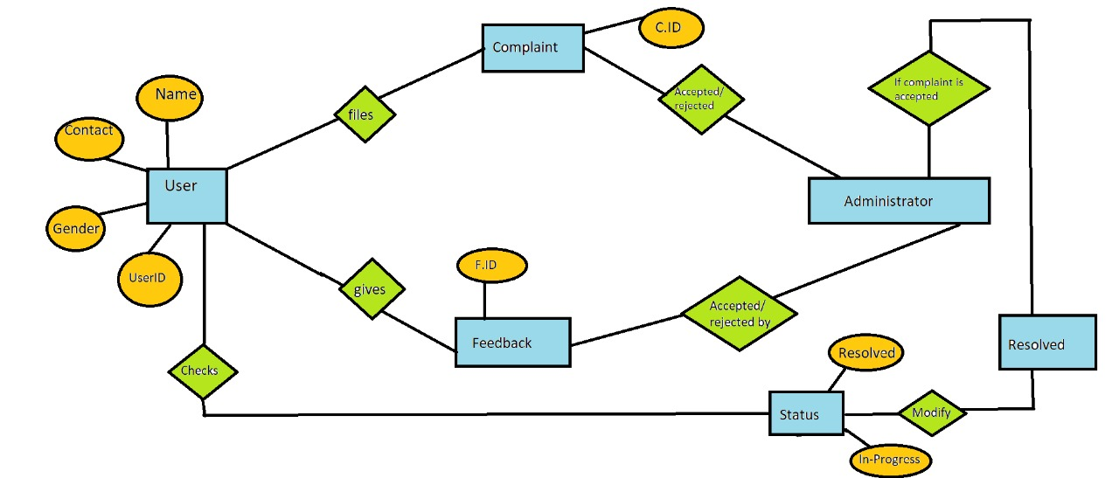

**2. STUDENT**

**2.1**  Students can file complaint and give feedback and can check status of his complaints.



**Tables**

Tables are listed below –

## USER

|  |  |  |  |
| --- | --- | --- | --- |
| **Field Name** | **Data type** | **Constraints** | **Comments** |
| userID | varchar(15) | NN | Username of the user and administrator. |
| pwd | varchar(20) | NN | Password of the user and administrator. |
| name | varchar(20) | NN | Name of the user. |
| pno | bigint | NN | Phone Number of the user |
| email | varchar(40) | NN | Email ID of the user |
| age | int(3) | NN | Age of the user |
| gender | Varchar(20) | NN | Gender of the user |
| fname | Varchar(20) | NN | Father’s name of the user |
| fno | bigint | NN | Father’s Phone number of the father |
| curAdd | Varchar(200) | NN | Current Address of the user |
| perAdd | Varchar(200) | NN | Permanent Address of the user |
| college | Varchar(100) | NN | College Name of the user. |
| univ | Varchar(100) | NN | University Name of the user. |
| State | Varchar(40) | NN | State in which the user’s college is located |
| city | Varchar(40) | NN | City in which the user’s college is located |

## Greivance

|  |  |  |  |
| --- | --- | --- | --- |
| **Field Name** | **Data type** | **Constraints** | **Comments** |
| grevID | Varchar(20) | NN | Holds the GrievanceID |
| userID | Varchar(20) | NN | Holds the userID of the user |
| Name | Varchar(20) | NN | Holds the name of the student |
| date | date | NN | Holds the date when the complaint is filed |
| text | text | NN | Holds the complaint |
| status | Varchar(20) | NN | Holds the status of the grievance |

## Feedback

|  |  |  |  |
| --- | --- | --- | --- |
| **Field Name** | **Data Type** | **Constraints** | **Comments** |
| feedID | Varchar(20) | NN | FeedbackID |
| userID | Varchar(20) | NN | Hold User ID |
| Name | Varchar(20) | NN | Holds the name of the user |
| date | Date | NN | Date when the feedback is sent |
| Text | Text | NN | Feedback text |
| status | Varchar(20) | NN | Status of the feedback |

**5. Implementation**

1. The new students must register with the portal before availing any services from it.
2. For each registration, maintain the complaints record in the database for the new user.
3. To reduce the usage of paper and maintain the database and updating according to the needs is the key area of concern.
4. When the student wants to register complaint they can apply online using this application and later approved by the administrator.
5. Every user student has to register first to get the access first.
6. The administrator has the access of student’s complaints.
7. Students may review their progress.
8. The online record provided by the portal may prove useful to the students.
9. Student’s complaint is seen step by step on the portal.

**CODING OF MODULES**

The developed system can be divided into four major modules namely:

* Home
* Login
* Signup
* User
* Administrator

Each of these modules has certain specific functionality related to them and are described below:-

* **Home**

This is the main home page that is visible to everyone:

Code for Home.html:

<!DOCTYPE html>

<html>

<head>

<title></title>

<link rel=*"stylesheet"* type=*"text/css"* href=*"Home.css"*>

<link rel=*"stylesheet"* href=*"https://stackpath.bootstrapcdn.com/bootstrap/4.3.1/css/bootstrap.min.css"*>

<script src=*"https://code.jquery.com/jquery-3.3.1.slim.min.js"* ></script>

<script src=*"https://cdnjs.cloudflare.com/ajax/libs/popper.js/1.14.7/umd/popper.min.js"* ></script>

<script src=*"https://stackpath.bootstrapcdn.com/bootstrap/4.3.1/js/bootstrap.min.js"* ></script>

<link rel=*"stylesheet"* href=*"https://stackpath.bootstrapcdn.com/font-awesome/4.7.0/css/font-awesome.min.css"*>

<link rel=*"stylesheet"* href=*"https://cdnjs.cloudflare.com/ajax/libs/animate.css/3.7.2/animate.min.css"*>

</head>

<body background=*"https://images.pexels.com/photos/5836/yellow-metal-design-decoration.jpg?cs=srgb&dl=art-creative-design-5836.jpg&fm=jpg"*>

<!-------------------Header------------------>

<section id=*"header"*>

<nav class=*"navbar navbar-light"*>

<a class=*"navbar-brand"* href=*"Home.html"* style="width: *30px*"><img src=*"images/atp3.jpg"* width=*"30px"*></a>

<button class=*"navbar-toggler"* type=*"button"* data-toggle=*"collapse"* data-target=*"#navbarNav"* aria-controls=*"navbarNav"* aria-expanded=*"false"* aria-label=*"Toggle navigation"*>

<i class=*"fa fa-bars"*></i>

</button>

<div class=*"collapse navbar-collapse"* id=*"navbarNav"*>

<ul class=*"navbar-nav"*>

<li class=*"nav-item"*>

<a class=*"navbar-brand"* href=*"#About"*>About</a>

</li>

<li class=*"nav-item"*>

<a class=*"navbar-brand"* href=*"login.html"*>Login</a>

</li>

<li class=*"nav-item"*>

<a class=*"navbar-brand"* href=*"#Social"*>Contact Us</a>

</li>

</ul>

</div>

</nav>

</section>

<!------------------------Welcome Text--------------->

<section id=*"welcome"*>

<div class=*"container"*>

<div class=*"welcome text-center wow fadeInUp "*>

<h1>Anti Ragging Portal</h1>

<p style="font-size: *20px*">Be the change you want to see in the world...</p>

<p style="font-size: *20px*">SAY NO TO RAGGING</p>

</div>

</div>

</section>

<!-------------------------------About Us------------------>

<section id=*"About"*>

<div class=*"container"*>

<div class=*"row"*>

<div class=*"col-md-6 text-center wow fadeInLeft"*>

<img src=*"images/rag.jpg"* class=*"img-fluid"*>

</div>

<div class=*"col-md-6 text-justify wow fadeInRight"*>

<h2 style="font-size: *25px*">About Anti Ragging</h2>

<p style="font-size: *20px*">Ragging is a criminal offence.</p>

<p style="font-size: *20px*">Don't "RAG" also don't be a mute witness to Ragging.</p>

<p style="font-size: *20px*">Ragging is strictly prohibited.</p>

<p style="font-size: *20px*">Ragging is a criminal offence.</p>

<p style="font-size: *20px*">It might cost you! Say no to Ragging.</p>

</div>

<div class=*"col-md-6"*>

<div class=*"col-md-6 text-justify wow fadeInLeft "*>

<h3 style="font-size: *25px*">Towards Ragging Free Campus</h3>

<p style="font-size: *20px*">Ragging is a criminal offence.</p>

<p style="font-size: *20px*">Don't "RAG" also don't be a mute witness to Ragging.</p>

<p style="font-size: *20px*">Ragging is strictly prohibited.</p>

<p style="font-size: *20px*">Ragging is a criminal offence.</p>

<p style="font-size: *20px*">It might cost you. Say no to ragging.</p>

</div>

</div>

<div class=*"col-md-6 text-center wow fadeInRight"*>

<div class=*"embed-responsive embed-responsive-16by9"*>

<iframe class=*"embed-responsive-item"* src=*"https://www.youtube.com/embed/PKUZ6HUiLFY"* frameborder=*"0"* allow=*"accelerometer; autoplay; encrypted-media; gyroscope; picture-in-picture"* allowfullscreen></iframe>

</div>

</div>

</div>

</div>

</section>

<!-----------------Social Media----------------->

<section id=*"Social"* style="background-color: *white*">

<div class=*"container"*>

<div class=*"row"*>

<div class=*"col-md-3"*>

<h1 style="font-size: *30px*">Contact</h1>

<p style="font-size: *20px*"><i class=*"fa fa-phone-square"*></i> +91 8800563204 </p>

<p style="font-size: *20px*"><i class=*"fa fa-envelope"*></i> xyz@ABC.com</p>

<p style="font-size: *20px*"><a href=*"https://www.kccitm.college/#contact"*><i class=*"fa fa-address-card"*></i></a> KCC,knowledge park III,2B-2C</p>

<p class=*"noida"* style="font-size: *20px*"> Greater Noida,India </p>

</div>

<div class=*"col-md-3"*>

<h1 style="font-size: *30px*">Follow Us On</h1>

<p style="font-size: *20px*"><a href=*"https://www.facebook.com/"*><i class=*"fa fa-facebook-official"*></i></a> Facebook</p>

<p style="font-size: *20px*"><a href=*"https://www.instagram.com/"*><i class=*"fa fa-instagram"*></i></a> Instagram</p>

<p style="font-size: *20px*"><a href=*"https://twitter.com/?lang=en"*><i class=*"fa fa-twitter"*></i></a> Twitter</p>

</div>

</div>

</div>

</section>

<!----------------smooth scroll js---------------->

<script src=*"images/smooth-scroll.js"*></script>

<script>

**var** scroll = **new** SmoothScroll('a[href*="#"]');

</script>

<!---------animation--------->

<script src=*"images/wow.min.js"*></script>

<script>

**new** WOW().init();

</script>

</body>

</html>

**Code for Home.css:**

*

{

padding: *0*;

margin: *0*;

}

*#header*

{

background-image: *url(images/banner.jpg)*;

height: *60vh*;

background-size: *cover*;

background-position: *center*;

}

*.navbar-nav* **li** **a**

{

float: *right*;

color: *black*;

}

*.navbar-brand* **img**

{

width: *70px*;

margin-left: *5px*;

border-radius: *12px*;

}

*.navbar-toggler*

{

border: *none*;

outline: *none*;

}

**nav** *.fa-bars*

{

color: *black*;

font-size: *25px*;

}

/-------------------**-welcome** **text--------------**/

*.welcome*

{

padding: *10px* *30px*;

margin-top: *-100px*;

background-color: *white*;

box-shadow: *0* *0* *20px* *70px* *rgba(0,0,0,0.2)*;

border-radius: *12px*;

font-size: *20px*;

}

*.welcome* **h1**

{

color: *brown*;

}

/--------------------**-About-----------------**/

*#About*

{

padding-top: *100px*;

padding-bottom: *100px*;

}

*#About* *.col-md-6*

{

padding: *20px* *5px*;

}

*#About* **h2**

{

margin: *20px* *auto*;

padding-left: *30px*;

}

*#About* **p**

{

padding-left: *30px*;

font-size: *20px*;

}

*#About* **h3**

{

margin: *0px* *auto*;

padding-left: *0px*;

}

*#About* **p**

{

padding-left: *30px*;

font-size: *20px*;

}

*#About* **iframe**

{

padding-left: *20px*;

}

/--------------**-Social** **Media-------------**/

*#Social*

{

margin-top: *50px*;

padding: *20px*;

background-color: *white*;

color: *black*;

}

*#Social* **h1**

{

font-size: *15px*;

text-align: *left*;

margin-top: *25px*;

margin-bottom: *25px*;

}

*#Social* *.noida*

{

margin-left: *35px*;

}

*#Social* *.fa*

{

padding-right: *20px*;

font-size: *15px*;

}

* **Login**

Login is a very important module of the project ANTI RAGGING PORTAL as everyone may it be admin or user has to first login to access any functionality.

Login: The administrator and user logs into the system

**Code for Login.html:-**

<!DOCTYPE html>

<html>

<head>

<title></title>

<link rel=*"stylesheet"* type=*"text/css"* href=*"login.css"*>

<link rel=*"stylesheet"* href=*"https://stackpath.bootstrapcdn.com/bootstrap/4.3.1/css/bootstrap.min.css"*>

<script src=*"https://code.jquery.com/jquery-3.3.1.slim.min.js"* ></script>

<script src=*"https://cdnjs.cloudflare.com/ajax/libs/popper.js/1.14.7/umd/popper.min.js"* ></script>

<script src=*"https://stackpath.bootstrapcdn.com/bootstrap/4.3.1/js/bootstrap.min.js"* ></script>

</head>

<body>

<nav class=*"navbar navbar-light"*>

<a class=*"navbar-brand"* href=*"Home.html"*><img src=*"images/atp3.jpg"* style="width: *20mm*"></a>

</nav>

<section id=*"welcome"*>

<div class=*"container"*>

<div class=*"welcome text-center wow fadeInUp "*>

<h1>Anti Ragging Portal</h1>

</div>

</div>

</section>

<div class=*"loginbox"*>

<img src=*"images/avatar.png"* class=*"avatar"*>

<h1>Login Here</h1>

<form method=*"get"* action=*"loginServlet"*>

<p>Username</p>

<input type=*"text"* name=*"userID"* placeholder=*"Enter Username"*>

<p>Password</p>

<input type=*"password"* name=*"pwd"* placeholder=*"Enter Password"* value=*""* id=*"myInput"*>

<input type=*"submit"* name=*"b1"* value=*"Login"*>

<!--<a href="#">Forgot Password</a><br>-->

Don't have an account?

<a href=*"signup.html"*> Sign Up</a>

</form>

</div>

</body>

</html>

**Code for Login.css:-**

**body**

{

margin: *0*;

padding: *0*;

background: *url(images/xy.jpeg)*;

background-size: *75cm*;

background-position: *center*;

font-family: *sans-serif*;

}

*.navbar-brand* **img**

{

width: *100mm*;

margin-left: *5px*;

border-radius: *12px*;

}

*.loginbox*

{

width: *320px*;

height: *440px*;

background: *#000*;

color: *white*;

top: *60%*;

left: *50%*;

position: *absolute*;

transform: *translate(-50%,-50%)*;

box-sizing: *border-box*;

padding: *70px* *30px*;

border-radius: *50px*;

}

*.avatar*

{

width: *100px*;

height: *100px*;

border-radius: *50%*;

position: *absolute*;

top: *-50px*;

left: *calc(50%* - *50px)*;

}

**h1**

{

margin: *0*;

padding: *0* *0* *20px*;

text-align: *center*;

font-size: *20px*;

}

*.welcome*

{

padding: *10px* *30px*;

margin-top: *-10px*;

background-image: *url(images/xy.jpeg)*;

box-shadow: *0* *0* *20px* *70px* *rgba(0,0,0,0.2)*;

border-radius: *12px*;

}

*.welcome* **h1**

{

color: *white*;

}

*.loginbox* **p**

{

margin: *0*;

padding: *0*;

font-weight: *bold*;

}

*.loginbox* **input**

{

width: *100%*;

margin-bottom: *20px*;

}

*.loginbox* **input**[type="text"]**,** **input**[type="password"]

{

border: *none*;

border-bottom: *1px* *solid* *white*;

background: *transparent*;

outline: *none*;

height: *40px*;

color: *white*;

font-size: *15px*;

}

*.loginbox* **input**[type="submit"]

{

border: *none*;

outline: *none*;

height: *40px*;

background: *red*;

color: *white*;

font-size: *18px*;

border-radius: *20px*;

}

*.loginbox* **input**[type="submit"]*:hover*

{

cursor: *pointer*;

background: *orange*;

color: *black*;

}

*.loginbox* **a**

{

text-decoration: *none*;

font-size: *10px*;

line-height: *20px*;

color: *yellow*;

}

*.loginbox* **a***:hover*

{

color: *orange*;

}

**Code for Login Servlet:-**

import java.io.IOException;

import java.io.PrintWriter;

import java.sql.*;

import javax.servlet.ServletException;

import javax.servlet.http.*;

public class loginServlet extends HttpServlet {

private static final long serialVersionUID = 1L;

protected void doGet(HttpServletRequest request, HttpServletResponse response) throws ServletException, IOException {

PrintWriter out = response.getWriter();

response.setContentType("text/html");

int flag = 0;

String userID = request.getParameter("userID");

String pwd = request.getParameter("pwd");

if(userID.isEmpty() || pwd.isEmpty())

{

out.println("<script type=\"text/javascript\">");

out.println("alert('You must fill both the fields');");

out.println("location='login.html';");

out.println("</script>");

}

if(userID.equals("admin") && pwd.equals("admin"))

{

response.sendRedirect("http://localhost:8080/AntiRagging/admin.jsp");

}

else

{

try

{

Connection conn = DBConnection.dbConnection();

Statement st = conn.createStatement();

ResultSet rs = st.executeQuery("select userID, pwd, name from user");

while(rs.next())

{

if(userID.equals(rs.getString(1)) && pwd.equals(rs.getString(2)))

{

HttpSession hs = request.getSession();

hs.setAttribute("uID", userID);

hs.setAttribute("name", rs.getString(3));

response.sendRedirect("http://localhost:8080/AntiRagging/user.jsp");

}

}

st.close();

conn.close();

out.println("<script type=\"text/javascript\">");

out.println("alert('UserID or password incorrect');");

out.println("location='login.html';");

out.println("</script>");

}

catch(Exception e)

{

e.printStackTrace();

}

}

}

}

* **Signup**

Another important module as any new user would have to signup and create a new account.

**Code for Signup.html**

<!DOCTYPE html>

<html>

<head>

<title></title>

<link rel=*"stylesheet"* type=*"text/css"* href=*"signup.css"*>

<link rel=*"stylesheet"*

href=*"https://fonts.googleapis.com/css?family=play"*>

<link rel=*"stylesheet"*

href=*"https://stackpath.bootstrapcdn.com/bootstrap/4.3.1/css/bootstrap.min.css"*>

<script src=*"https://code.jquery.com/jquery-3.3.1.slim.min.js"*></script>

<script

src=*"https://cdnjs.cloudflare.com/ajax/libs/popper.js/1.14.7/umd/popper.min.js"*></script>

<script

src=*"https://stackpath.bootstrapcdn.com/bootstrap/4.3.1/js/bootstrap.min.js"*></script>

</head>

<body>

<nav class=*"navbar navbar-light"*>

<a class=*"navbar-brand"* href=*"Home.html"*><img

src=*"images/atp3.jpg"* style="width: *20mm*"></a>

</nav>

<section id=*"welcome"*>

<div class=*"container"*>

<div class=*"welcome text-center wow fadeInUp "*>

<h1>Anti Ragging Portal</h1>

</div>

</div>

</section>

<br><br>

<div class=*"signup"*>

<form method=*"get"* action=*"signup.jsp"*>

<h2 style="color: *white*;">Sign Up</h2>

<input id=*name* type=*"text"* name=*"name"* placeholder=*"Name"* required><br>

<br> +91<input type=*"number"* name=*"pno"*

placeholder=*"Phone Number"* required><br> <br> <input

type=*"email"* name=*"email"* placeholder=*"Email Address"* required><br>

<br> <input type=*"number"* name=*"age"* placeholder=*"Age"* required><br>

<br> <input type=*"text"* name=*"gender"* placeholder=*"Gender"*

required><br> <br> <input type=*"text"* name=*"Fname"*

placeholder=*"Father's Name"* required><br> <br> +91<input

type=*"number"* name=*"fno"* placeholder=*"Father's Phone Number"*

required><br> <br> <input type=*"text"*

name=*"curAdd"* placeholder=*"Current Address"* required><br>

<br> <input type=*"text"* name=*"perAdd"*

placeholder=*"Permanent Address"* required><br> <br>

<input type=*"text"* name=*"college"* placeholder=*"College Name"* required><br>

<br> <input type=*"text"* name=*"univ"* placeholder=*"University"*

required><br> <br>

<!-- <input type="text" name="state" placeholder="State" required><br><br>-->

<select name=*state* class=*"select"* required style="color: *white*">

<option value=*""* style="background-color: *black* ;color: *white*;">Select State</option>

<option value=*"Andaman and Nicobar Islands"* style="background-color: *black* ;color: *white*;">Andaman and

Nicobar Islands</option>

<option value=*"Andhra Pradesh"* style="background-color: *black* ;color: *white*;">Andhra Pradesh</option>

<option value=*"Arunachal Pradesh"* style="background-color: *black* ;color: *white*;">Arunachal Pradesh</option>

<option value=*"Assam"* style="background-color: *black* ;color: *white*;">Assam</option>

<option value=*"Bihar"* style="background-color: *black* ;color: *white*;">Bihar</option>

<option value=*"Chandigarh"* style="background-color: *black* ;color: *white*;">Chandigarh</option>

<option value=*"Chhattisgarh"* style="background-color: *black* ;color: *white*;">Chhattisgarh</option>

<option value=*"Dadra and Nagar Haveli"* style="background-color: *black* ;color: *white*;">Dadra and Nagar

Haveli</option>

<option value=*"Daman and Diu"* style="background-color: *black* ;color: *white*;">Daman and Diu</option>

<option value=*"Delhi"* style="background-color: *black* ;color: *white*;">Delhi</option>

<option value=*"Goa"* style="background-color: *black* ;color: *white*;">Goa</option>

<option value=*"Gujarat"* style="background-color: *black* ;color: *white*;">Gujarat</option>

<option value=*"Haryana"* style="background-color: *black* ;color: *white*;">Haryana</option>

<option value=*"Himachal Pradesh"* style="background-color: *black* ;color: *white*;">Himachal Pradesh</option>

<option value=*"Jammu and Kashmir"* style="background-color: *black* ;color: *white*;">Jammu and Kashmir</option>

<option value=*"Jharkhand"* style="background-color: *black* ;color: *white*;">Jharkhand</option>

<option value=*"Karnataka"* style="background-color: *black* ;color: *white*;">Karnataka</option>

<option value=*"Kerala"* style="background-color: *black* ;color: *white*;">Kerala</option>

<option value=*"Lakshadweep"* style="background-color: *black* ;color: *white*;">Lakshadweep</option>

<option value=*"Madhya Pradesh"* style="background-color: *black* ;color: *white*;">Madhya Pradesh</option>

<option value=*"Maharashtra"* style="background-color: *black* ;color: *white*;">Maharashtra</option>

<option value=*"Manipur"* style="background-color: *black* ;color: *white*;">Manipur</option>

<option value=*"Meghalaya"* style="background-color: *black* ;color: *white*;">Meghalaya</option>

<option value=*"Mizoram"* style="background-color: *black* ;color: *white*;">Mizoram</option>

<option value=*"Nagaland"* style="background-color: *black* ;color: *white*;">Nagaland</option>

<option value=*"Orissa"* style="background-color: *black* ;color: *white*;">Orissa</option>

<option value=*"Pondicherry"* style="background-color: *black* ;color: *white*;">Pondicherry</option>

<option value=*"Punjab"* style="background-color: *black* ;color: *white*;">Punjab</option>

<option value=*"Rajasthan"* style="background-color: *black* ;color: *white*;">Rajasthan</option>

<option value=*"Sikkim"* style="background-color: *black* ;color: *white*;">Sikkim</option>

<option value=*"Tamil Nadu"* style="background-color: *black* ;color: *white*;">Tamil Nadu</option>

<option value=*"Tripura"* style="background-color: *black* ;color: *white*;">Tripura</option>

<option value=*"Uttaranchal"* style="background-color: *black* ;color: *white*;">Uttaranchal</option>

<option value=*"Uttar Pradesh"* style="background-color: *black* ;color: *white*;">Uttar Pradesh</option>

<option value=*"West Bengal"* style="background-color: *black* ;color: *white*;">West Bengal</option>

</select><br> <br> <input type=*"text"* name=*"city"* placeholder=*"City"*

required><br> <br> <input type=*"password"*

name=*"pwd"* placeholder=*"Password"* required><br> <br>

<input type=*"password"* name=*"cpwd"* placeholder=*"Confirm Password"*

required><br> <br> <input type=*"submit"* name=*"b1"*

value=*"signup"*><br> <br> Already have account?<a

href=*"login.html"*

style="text-decoration: *none*; font-family: *'play', san-serif*; color: *yellow*;">Login</a>

</form>

</div>

</body>

</html>

**Code for Signup.css**

**body**

{

font-family: *sans-serif*;

color: *white*;

background: *url(images/pic8.jpg)*;

background-size: *cover*;

}

*.navbar-brand* **img**

{

width: *70px*;

margin-left: *5px*;

}

*.signup*

{

background: *rgba(44,62,80,0.7)*;

padding: *40px*;

width: *310px*;

margin: *auto*;

margin-top: *80px*;

height: *1020px*;

margin-left: *180px*;

margin-top: *90px*;

margin: *0* *auto*;

}

**form**

{

width: *240px*;

text-align: *center*;

color: *white*;

}

*.welcome*

{

padding: *10px* *30px*;

margin-top: *-10px*;

background-image: *url(images/pic8.jpg)*;

box-shadow: *0* *0* *20px* *70px* *rgba(0,0,0,0.2)*;

border-radius: *12px*;

}

*.welcome* **h1**

{

color: *white*;

}

**input**

{

/width: *240px*;/

text-align: *center*;

background: *transparent*;

border: *none*;

border-bottom: *1px* *solid* *white*;

font-family: *'play',* *sans-serif*;

font-size: *16px*;

font-weight: *200px*;

padding: *10px* *0*;

transition: *border* *0.5s*;

outline: *none*;

color: *white*;

}

**select**

{

width: *200px*;

text-align: *center*;

background: *transparent*;

border: *none*;

border-bottom: *1px* *solid* *white*;

font-family: *'play',* *sans-serif*;

font-size: *16px*;

font-weight: *200px*;

padding: *10px* *0*;

transition: *border* *0.5s*;

outline: *none*;

color: *white*;

}

**input**[type=submit]

{

border: *none*;

width: *190px*;

background: *orange*;

color: *white*;

font-size: *16px*;

line-height: *25px*;

padding: *10px* *0*;

border-radius: *15px*;

}

**input**[type=submit]*:hover*

{

cursor: *pointer*;

color: *white*;

background-color: *black*;

}

**Code for Signup.jsp**

<%@ page language=*"java"* contentType=*"text/html; charset=ISO-8859-1"*

pageEncoding=*"ISO-8859-1"* import=*"java.sql.*"*%>

<!DOCTYPE html PUBLIC "-//W3C//DTD HTML 4.01 Transitional//EN" "http://www.w3.org/TR/html4/loose.dtd">

<html>

<head>

<meta http-equiv=*"Content-Type"* content=*"text/html; charset=ISO-8859-1"*>

<title>Insert title here</title>

</head>

<body>

<%!**public** **boolean** checkName(String name) {

String specialChars = "~`!@#$%^&*()-_=+\\|[{]};:'\",<.>/?";

**char** currentCharacter;

**boolean** n = **true**;

**for** (**int** i = 0; i < name.length(); i++) {

currentCharacter = name.charAt(i);

**if** (Character.isDigit(currentCharacter))

n = **false**;

**else** **if** (specialChars.contains(String.valueOf(currentCharacter)))

n = **false**;

}

**return** n;

}

**public** **boolean** checkAge(**int** age) {

**boolean** n = **true**;

**if** (age > 40)

n = **false**;

**return** n;

}

**public** **boolean** checkNum(**long** num) {

**boolean** n = **true**;

**if** (String.valueOf(num).length() != 10) {

n = **false**;

}

**return** n;

}%>

<%

String pwd = request.getParameter("pwd");

String cpwd = request.getParameter("cpwd");

**if** (pwd.equals(cpwd)) {

String name = request.getParameter("name");

**boolean** status_name = checkName(name);

**if** (status_name == **false**) {

out.println("<script type=\"text/javascript\">");

out.println("alert('Name must not have special characters or numbers');");

out.println("location='signup.html';");

out.println("</script>");

} **else** {

**long** pno = Long.parseLong(request.getParameter("pno"));

**boolean** status_pno = checkNum(pno);

**if** (status_pno == **false**) {

out.println("<script type=\"text/javascript\">");

out.println("alert('Length of Phone Number cannot exceed 10');");

out.println("location='signup.html';");

out.println("</script>");

} **else** {

**long** fno = Long.parseLong(request.getParameter("fno"));

**boolean** status_fno = checkNum(fno);

**if** (status_fno == **false**) {

out.println("<script type=\"text/javascript\">");

out.println("alert('Length of Phone Number must not exceed 10');");

out.println("location='signup.html';");

out.println("</script>");

} **else** {

**int** age = Integer.parseInt(request.getParameter("age"));

**boolean** status_age = checkAge(age);

**if** (status_age == **false**) {

out.println("<script type=\"text/javascript\">");

out.println("alert('Age must not be more than 40');");

out.println("location='signup.html';");

out.println("</script>");

} **else** {

String gender = request.getParameter("gender");

String Fname = request.getParameter("Fname");

String email = request.getParameter("email");

String curAdd = request.getParameter("curAdd");

String perAdd = request.getParameter("perAdd");

String college = request.getParameter("college");

String univ = request.getParameter("univ");

String state = request.getParameter("state");

String city = request.getParameter("city");

**try** {

Class.forName("com.mysql.jdbc.Driver");

Connection conn = DriverManager.getConnection(

"jdbc:mysql://localhost:3306/AntiRagging", "root", "Ns422444");

Statement st = conn.createStatement();

ResultSet rst = st

.executeQuery("select userID from user order by userID DESC LIMIT 1");//fetch last userID

rst.next();

String str = rst.getString(1);

String[] str_spl = str.split("[-]");

**int** id = Integer.parseInt(str_spl[1]) + 1;

String userID = "usr-" + id;

st.close();

PreparedStatement pst = conn

.prepareStatement("insert into user values(?,?,?,?,?,?,?,?,?,?,?,?,?,?,?)");

pst.setString(1, userID); //userID as provided by developers

pst.setString(2, pwd); //password as given by user

pst.setString(3, name); //name as given by user

pst.setLong(4, pno); //phone number as given by user

pst.setString(5, email); //email as given by user

pst.setInt(6, age); //age as given by user

pst.setString(7, gender); //gender as given by user

pst.setString(8, Fname); //father's name as given by user

pst.setLong(9, fno); //father's phone number as given by user

pst.setString(10, curAdd); //current address as given by user

pst.setString(11, perAdd); //permanent address as given by user

pst.setString(12, college); //college name as given by user

pst.setString(13, univ); //university name as given by user

pst.setString(14, state); //state as given by user

pst.setString(15, city); //city as given by user

pst.execute();

pst.close();

session.setAttribute("uID", userID);

session.setAttribute("pwd", pwd);

response.sendRedirect("http://localhost:8080/AntiRagging/display.jsp");

} //TRY for database connection ends here

**catch** (Exception e) {

e.printStackTrace();

}

}

}

}

}

} //IF ends here

**else** {

out.println("<script type=\"text/javascript\">");

out.println("alert('Password and Confirm Password does not match');");

out.println("location='signup.html';");

out.println("</script>");

}

%>

</body>

</html>

* **User**

The main user that signs-up or logs-in is sent to a page to perform certain operations that only the user can perform

**Code for User.jsp**

<%@ page language=*"java"* contentType=*"text/html; charset=ISO-8859-1"*

pageEncoding=*"ISO-8859-1"*%>

<!DOCTYPE html PUBLIC "-//W3C//DTD HTML 4.01 Transitional//EN" "http://www.w3.org/TR/html4/loose.dtd">

<html>

<head>

<meta http-equiv=*"Content-Type"* content=*"text/html; charset=ISO-8859-1"*>

<title>Anti Ragging Portal</title>

<link rel=*"stylesheet"* type=*"text/css"* href=*"user.css"*>

<link rel=*"stylesheet"* href=*"https://stackpath.bootstrapcdn.com/bootstrap/4.3.1/css/bootstrap.min.css"*>

<script src=*"https://code.jquery.com/jquery-3.3.1.slim.min.js"* ></script>

<script src=*"https://cdnjs.cloudflare.com/ajax/libs/popper.js/1.14.7/umd/popper.min.js"* ></script>

<script src=*"https://stackpath.bootstrapcdn.com/bootstrap/4.3.1/js/bootstrap.min.js"* ></script>

<link rel=*"stylesheet"* href=*"https://stackpath.bootstrapcdn.com/font-awesome/4.7.0/css/font-awesome.min.css"* type=*"text/css"*>

</head>

<body background=*"images/yel.jpeg"*>

<section id=*"header"*>

<nav class=*"navbar navbar-light"*>

<a class=*"navbar-brand"* href=*"Homeuser.html"*><img src=*"images/atp3.jpg"*></a>

<div id=*"mydiv"* style="font-size: *20px*">

<%

out.print((String)session.getAttribute("uID"));

%>

<a href=*"login.html"*><input type=*"button"* name=*"logout"* value=*"Logout"* style="border-radius: *12px*;background-color: *black*; color:*white*; border-color: *transparent*;border-width: *5px*"></a>

</div>

</nav>

</section>

<section id=*"welcome"*>

<div class=*"container"*>

<div class=*"welcome text-center wow fadeInUp "*>

<h1>Anti Ragging Portal</h1>

</div>

</div>

</section>

<!-------------------Button 3D--------------->

<ul>

<li>

<a href=*"grievance.jsp"*>

<i class=*"fa fa-eye"* aria-hidden=*"true"*></i>

<span>Raise Grievance</span>

</a>

</li>

<li>

<a href=*"feedback.jsp"*>

<i class=*"fa fa-commenting"* aria-hidden=*"true"*></i>

<span> Send Feedback </span>

</a>

</li>

<li>

<a href=*"checkStatus.jsp"*>

<i class=*"fa fa-pencil-square-o"* aria-hidden=*"true"*></i>

<span> Check Status </span>

</a>

</li>

</ul>

<!-----------------Social Media----------------->

<section id=*"Social"*>

<div class=*"container"*>

<div class=*"row"*>

<div class=*"col-md-3"*>

<h1 style="font-size: *30px*">Contact</h1>

<p style="font-size: *20px*"><i class=*"fa fa-phone-square"*></i> +91 8800563204 </p>

<p style="font-size: *20px*"><i class=*"fa fa-envelope"*></i> xyz@ABC.com</p>

<p style="font-size: *20px*"><a href=*"https://www.kccitm.college/#contact"*><i class=*"fa fa-address-card"*></i></a> KCC,knowledge park III,2B-2C</p>

<p class=*"noida"* style="font-size: *20px*"> Greater Noida,India </p>

</div>

<div class=*"col-md-3"*>

<h1 style="font-size: *30px*">Follow Us On</h1>

<p style="font-size: *20px*"><a href=*"https://www.facebook.com/"*><i class=*"fa fa-facebook-official"*></i></a> Facebook</p>

<p style="font-size: *20px*"><a href=*"https://www.instagram.com/"*><i class=*"fa fa-instagram"*></i></a> Instagram</p>

<p style="font-size: *20px*"><a href=*"https://twitter.com/?lang=en"*><i class=*"fa fa-twitter"*></i></a> Twitter</p>

</div>

</div>

</div>

</section>

</body>

</html>

**Code for User.css**

*

{

padding: *0*;

margin: *0*;

}

*#header*

{

background-image: *url(images/banner.jpg)*;

height: *60vh*;

background-size: *cover*;

background-position: *center*;

}

*.navbar-nav* **li** **a**

{

float: *right*;

color: *black*;

}

*.navbar-brand* **img**

{

width: *70px*;

border-radius:*12px*;

margin-left: *5px*;

}

*.welcome*

{

padding: *10px* *30px*;

margin-top: *-565px*;

background-image: *url(images/banner.jpg)*;

box-shadow: *0* *0* *1px* *3px* *rgba(0,0,0,0.2)*;

border-radius: *12px*;

}

*.welcome* **h1**

{

color: *brown*;

}

*#mydiv*

{

margin: *0*;

padding-left: *50px*;

}

/*---------------Button 3D-------------*/

**body**

{

font-family: *sans-serif*;

}

**ul**

{

position: *absolute*;

top: *75%*;

left: *45%*;

transform: *translate(-50%,* *-50%)*;

display: *flex*;

margin: *0*;

padding: *0*;

}

**ul** **li**

{

list-style: *none*;

margin: *0* *5px*;

}

**ul** **li** **a** *.fa*

{

font-size: *40px*;

color: *#333*;

line-height: *80px*;

transition: *0.5s*;

padding-right: *14px*;

}

**ul** **li** **a** **span**

{

padding: *0*;

margin: *0*;

position: *absolute*;

top: *10px*;

color: *#333*;

letter-spacing: *4px*;

transition: *0.5s*;

}

**ul** **li** **a**

{

text-decoration: *none*;

display: *absolute*;

display: *block*;

width: *210px*;

height: *80px*;

background: *#fff*;

text-align: *left*;

padding-left: *20px*;

transform: *rotate(-30deg)* *skewX(25deg)* *translate(0,0)*;

transition: *0.5s*;

box-shadow: *-20px* *20px* *10px* *rgba(0,0,0,0.5)*;

}

**ul** **li** **a***:before*

{

content: *''*;

position: *absolute*;

top: *10px*;

left: *-20px*;

height: *100%*;

width: *20px*;

background: *#b1b1b1*;

transform: *0.5s*;

transform: *rotate(0deg)* *skewY(-45deg)*;

}

**ul** **li** **a***:after*

{

content: *''*;

position: *absolute*;

bottom: *-20px*;

left: *-10px*;

height: *20px*;

width: *100%*;

background: *#b1b1b1*;

transform: *0.5s*;

transform: *rotate(0deg)* *skewX(-45deg)*;

}

**ul** **li** **a***:hover*

{

transform: *rotate(-30deg)* *skew(25deg)* *translate(20px,-15px)*;

box-shadow: *-50px* *50px* *50px* *rgba(0,0,0,0.5)*;

}

**ul** **li***:hover* *.fa*

{

color: *#fff*;

}

**ul** **li***:hover* **span**

{

color: *#fff*;

}

**ul** **li***:hover* **a**

{

background: *#dd4b39*;

}

**ul** **li***:hover* **a***:before*

{

background: *#b33a2b*;

}

**ul** **li***:hover* **a***:after*

{

background: *#e66a5a*;

}

/*---------------Social Media-------------*/

*#Social*

{

margin-top: *900px*;

padding: *50px*;

background-color: *#efefef*;

color: *#013f7e*;

}

*#Social* **h1**

{

font-size: *20px*;

text-align: *center*;

margin-top: *5px*;

margin-bottom: *5px*;

}

*#Social* *.noida*

{

margin-left: *35px*;

}

*#Social* *.fa*

{

padding-right: *20px*;

font-size: *15px*;

}

**Code for Raise Grievance**

<%@page import=*"java.util.Calendar"*%>

<%@ page language=*"java"* contentType=*"text/html; charset=ISO-8859-1"*

pageEncoding=*"ISO-8859-1"* import=*"java.sql.*, java.util.*"*%>

<!DOCTYPE html>

<html>

<head>

<title>Grievance</title>

<link rel=*"stylesheet"* type=*"text/css"* href=*"feedback.css"*>

<link rel=*"stylesheet"*

href=*"https://stackpath.bootstrapcdn.com/bootstrap/4.3.1/css/bootstrap.min.css"*>

<script src=*"https://code.jquery.com/jquery-3.3.1.slim.min.js"*></script>

<script

src=*"https://cdnjs.cloudflare.com/ajax/libs/popper.js/1.14.7/umd/popper.min.js"*></script>

<script

src=*"https://stackpath.bootstrapcdn.com/bootstrap/4.3.1/js/bootstrap.min.js"*></script>

<link rel=*"stylesheet"*

href=*"https://stackpath.bootstrapcdn.com/font-awesome/4.7.0/css/font-awesome.min.css"*>

<link rel=*"stylesheet"*

href=*"https://cdnjs.cloudflare.com/ajax/libs/animate.css/3.7.2/animate.min.css"*>

</head>

<body

background=*"https://images.pexels.com/photos/5836/yellow-metal-design-decoration.jpg?cs=srgb&dl=art-creative-design-5836.jpg&fm=jpg"*>

<!-------------------Header------------------>

<section id=*"header"*>

<nav class=*"navbar navbar-light"*>

<a class=*"navbar-brand"* href=*"Homeuser.html"*><img

src=*"images/atp3.jpg"*></a>

<div id=*"mydiv"* style="font-size: *7mm*">

<%

out.print("UserID -> " + session.getAttribute("uID"));

%>

<a href=*"login.html"*> <%

//session.invalidate();

%><input type=*"button"* name=*"logout"* value=*"Logout"* style="border-radius: *12px*;border-color: *transparent*;background-color: *black*; color: *white*">

</a>

</div>

</nav>

</section>

<section id=*"welcome"*>

<div class=*"container"*>

<div class=*"welcome text-center wow fadeInUp "*>

<h1>Anti Ragging Portal</h1>

</div>

</div>

</section>

<!--------------------feedback------------->

<section id=*"feedback"*>

<div class=*"container"*>

<div class=*"feedback text-center "*>

<form method=*"get"* action=*insertGrievanceServlet*>

<h1>Grievance</h1>

<br>

<%

**try** {

Class.forName("com.mysql.jdbc.Driver");

Connection conn = DriverManager.getConnection("jdbc:mysql://localhost:3306/AntiRagging", "root",

"Ns422444");

PreparedStatement st = conn.prepareStatement("select name from user where userID=?");

st.setString(1, (String) session.getAttribute("uID"));

ResultSet rs = st.executeQuery();

rs.next();

out.print("<h5 style=color:white>Name : " + (String) session.getAttribute("name") + "</h5><br><br>");

out.print("<h5 style=color:white>UserID : " + (String) session.getAttribute("uID") + "</h5><br><br>");

//out.print(Calendar.getInstance());

} **catch** (Exception e) {

e.printStackTrace();

}

%>

<textarea cols=*"100"* rows=*"5"* name=*"grievance"*

placeholder=*"Enter The Grievance"* required></textarea>

<br><br> <input type=*"submit"* value=*"submit"*

style="color: *black*; background-color: *skyblue*; border-color: *transparent*; border-radius: *12px*; width: *80px*; height: *40px*; font-size: *20px*">

</form>

</div>

</div>

</section>

<!----------------Social Media----------------->

<section id=*"Social"*>

<div class=*"container"*>

<div class=*"row"*>

<div class=*"col-md-3"*>

<h1>Contact</h1>

<p>

<i class=*"fa fa-phone-square"*></i> +91 8800563204

</p>

<p>

<i class=*"fa fa-envelope"*></i> xyz@ABC.com

</p>

<p>

<a href=*"https://www.kccitm.college/#contact"*><i

class=*"fa fa-address-card"*></i></a> KCC,knowledge park III,2B-2C

</p>

<p class=*"noida"*>Greater Noida,India</p>

</div>

<div class=*"col-md-3"*>

<h1>Follow Us On</h1>

<p>

<a href=*"https://www.facebook.com/"*><i

class=*"fa fa-facebook-official"*></i></a> Facebook

</p>

<p>

<a href=*"https://www.instagram.com/"*><i

class=*"fa fa-instagram"*></i></a> Instagram

</p>

<p>

<a href=*"https://twitter.com/?lang=en"*><i

class=*"fa fa-twitter"*></i></a> Twitter

</p>

</div>

</div>

</div>

</section>

</body>

</html>

**Code for Raise Grievance Servlet**

import java.sql.*;

import java.io.IOException;

import java.io.PrintWriter;

import javax.servlet.ServletException;

import javax.servlet.http.*;

public class insertGrievanceServlet extends HttpServlet {

private static final long serialVersionUID = 1L;

protected void doGet(HttpServletRequest request, HttpServletResponse response) throws ServletException, IOException {

PrintWriter out = response.getWriter();

response.setContentType("text/html");

HttpSession hs=request.getSession();

try

{

Connection conn = DBConnection.dbConnection();

Statement st=conn.createStatement();

ResultSet rs=st.executeQuery("select grevID from grev order by grevID DESC LIMIT 1;");

rs.next();

String str=rs.getString(1);

String[] arr=str.split("[-]");

int grevInt=(Integer.parseInt(arr[1]))+1;

String grevID = "grev-"+grevInt;

PreparedStatement pst=conn.prepareStatement("insert into grev values(?,?,?,CURDATE(),?,'pending')");

pst.setString(1,grevID);

pst.setString(2,(String)hs.getAttribute("uID"));

pst.setString(3,(String)hs.getAttribute("name"));

pst.setString(4, (String)request.getParameter("grievance"));

pst.execute();

out.println("<script type=\"text/javascript\">");

out.println("alert('Your Grievance Has been recorded successfully');");

out.println("location='Homeuser.html';");

out.println("</script>");

}

catch(Exception e)

{

e.printStackTrace();

}

}

}

**Code for Send Feedback**

<%@page import=*"java.util.Calendar"*%>

<%@ page language=*"java"* contentType=*"text/html; charset=ISO-8859-1"*

pageEncoding=*"ISO-8859-1"* import=*"java.sql.*, java.util.*"*%>

<!DOCTYPE html>

<html>

<head>

<title></title>

<link rel=*"stylesheet"* type=*"text/css"* href=*"feedback.css"*>

<link rel=*"stylesheet"*

href=*"https://stackpath.bootstrapcdn.com/bootstrap/4.3.1/css/bootstrap.min.css"*>

<script src=*"https://code.jquery.com/jquery-3.3.1.slim.min.js"*></script>

<script

src=*"https://cdnjs.cloudflare.com/ajax/libs/popper.js/1.14.7/umd/popper.min.js"*></script>

<script

src=*"https://stackpath.bootstrapcdn.com/bootstrap/4.3.1/js/bootstrap.min.js"*></script>

<link rel=*"stylesheet"*

href=*"https://stackpath.bootstrapcdn.com/font-awesome/4.7.0/css/font-awesome.min.css"*>

<link rel=*"stylesheet"*

href=*"https://cdnjs.cloudflare.com/ajax/libs/animate.css/3.7.2/animate.min.css"*>

</head>

<body

background=*"https://images.pexels.com/photos/5836/yellow-metal-design-decoration.jpg?cs=srgb&dl=art-creative-design-5836.jpg&fm=jpg"*>

<!-------------------Header------------------>

<section id=*"header"* style="font-size: *30px*">

<nav class=*"navbar navbar-light"*>

<a class=*"navbar-brand"* href=*"Homeuser.html"*><img

src=*"images/atp3.jpg"*></a>

<div id=*"mydiv"* style="font-size: *7mm*">

<%

out.print("UserID -> " + session.getAttribute("uID"));

%>

<a href=*"login.html"*> <%

//session.invalidate();

%><input type=*"button"* name=*"logout"* value=*"Logout"* style="border-radius: *12px*;border-color: *transparent*;background-color: *black*; color: *white*">

</a><br>

</div>

</nav>

</section>

<section id=*"welcome"*>

<div class=*"container"*>

<div class=*"welcome text-center wow fadeInUp "*>

<h1>Anti Ragging Portal</h1>

</div>

</div>

</section>

<!--------------------feedback------------->

<section id=*"feedback"*>

<div class=*"container"*>

<div class=*"feedback text-center "*>

<form method=*"get"* action=*insertFeedbackServlet*>

<h1>Feedback</h1>

<br>

<%

**try** {

Class.forName("com.mysql.jdbc.Driver");

Connection conn = DriverManager.getConnection("jdbc:mysql://localhost:3306/AntiRagging", "root",

"Ns422444");

PreparedStatement st = conn.prepareStatement("select name from user where userID=?");

st.setString(1, (String)session.getAttribute("uID"));

ResultSet rs = st.executeQuery();

rs.next();

out.print("<h5 style=color:white>Name : " + (String) session.getAttribute("name") + "</h5><br><br>");

out.print("<h5 style=color:white>UserID : " + (String) session.getAttribute("uID") + "</h5><br><br>");

//out.print(Calendar.getInstance());

} **catch** (Exception e) {

e.printStackTrace();

}

%>

<textarea cols=*"100"* rows=*"5"* name=*"feedback"* placeholder=*"Enter The FeedBack"* required></textarea>

<br><br>

<input type=*"submit"* value=*"submit"* style="color: *black*; font-size: *20px* ;background-color: *skyblue*; border-color: *transparent*; border-radius: *12px*; width: *80px*; height: *40px*">

</form>

</div>

</div>

</section>

<!----------------Social Media----------------->

<section id=*"Social"*>

<div class=*"container"*>

<div class=*"row"*>

<div class=*"col-md-3"*>

<h1>Contact</h1>

<p style="font-size: *20px*">

<i class=*"fa fa-phone-square"*></i> +91 8800563204

</p>

<p style="font-size: *20px*">

<i class=*"fa fa-envelope"*></i> xyz@ABC.com

</p>

<p style="font-size: *20px*">

<a href=*"https://www.kccitm.college/#contact"*><i

class=*"fa fa-address-card"*></i></a> KCC,knowledge park III,2B-2C

</p>

<p class=*"noida"*>Greater Noida,India</p>

</div>

<div class=*"col-md-3"*>

<h1>Follow Us On</h1>

<p style="font-size: *20px*">

<a href=*"https://www.facebook.com/"*><i

class=*"fa fa-facebook-official"*></i></a> Facebook

</p>

<p style="font-size: *20px*">

<a href=*"https://www.instagram.com/"*><i

class=*"fa fa-instagram"*></i></a> Instagram

</p>

<p style="font-size: *20px*">

<a href=*"https://twitter.com/?lang=en"*><i

class=*"fa fa-twitter"*></i></a> Twitter

</p>

</div>

</div>

</div>

</section>

</body>

</html>

**Code for Send Feedback Servlet**

import java.sql.*;

import java.io.IOException;

import java.io.PrintWriter;

import javax.servlet.ServletException;

import javax.servlet.http.*;

public class insertFeedbackServlet extends HttpServlet {

private static final long serialVersionUID = 1L;

int feedId;

protected void doGet(HttpServletRequest request, HttpServletResponse response) throws ServletException, IOException {

response.setContentType("text/html");

PrintWriter out = response.getWriter();

HttpSession hs=request.getSession();

try

{

Connection conn = DBConnection.dbConnection();

Statement st=conn.createStatement();

ResultSet rs=st.executeQuery("select feedID from feedback order by feedID DESC LIMIT 1;");

while(rs.next())

{

String str=rs.getString(1);

String[] arr=str.split("[-]");

feedId=(Integer.parseInt(arr[1]))+1;

}

String feed = "feed-"+feedId;

PreparedStatement pst=conn.prepareStatement("insert into feedback values(?,?,?,CURDATE(),?,'pending')");

pst.setString(1, feed);

pst.setString(2,(String)hs.getAttribute("uID"));

pst.setString(3,(String)hs.getAttribute("name"));

pst.setString(4,(String)request.getParameter("feedback"));

pst.execute();

out.println("<script type=\"text/javascript\">");

out.println("alert('Your Feedback has been recorded successfully');");

out.println("location='Homeuser.html';");

out.println("</script>");

}

catch(Exception e)

{

e.printStackTrace();

}

}

}

**Code for Both Raise Grievance and Send Feedback CSS**

*

{

padding: *0*;

margin: *0*;

}

*#header*

{

background-image: *url(images/banner.jpg)*;

height: *60vh*;

background-size: *cover*;

background-position: *center*;

}

*.navbar-brand* **img**

{

width: *70px*;

margin-left: *5px*;

border-radius: *12px*;

}

*.feedback*

{

padding: *50px* *100px*;

margin-top: *300px*;

background-image: *url(images/xy.jpeg)*;

box-shadow: *0* *0* *20px* *7px* *rgba(0,0,0,0.2)*;

color: *red*;

}

*.welcome*

{

padding: *10px* *30px*;

margin-top: *-400px*;

background-image: *url(images/banner.jpg)*;

box-shadow: *0* *0* *1px* *3px* *rgba(0,0,0,0.2)*;

border-radius: *12px*;

}

*.welcome* **h1**

{

color: *brown*;

}

*.feedback* **h1**

{

color: *white*;

}

/--------------**-Social** **Media-------------**/

*#Social*

{

margin-top: *400px*;

padding: *0px*;

background-color: *#efefef*;

color: *#013f7e*;

}

*#Social* **h1**

{

font-size: *1cm*;

text-align: *left*;

margin-top: *25px*;

margin-bottom: *25px*;

}

*#Social* *.noida*

{

margin-left: *35px*;

}

*#Social* *.fa*

{

padding-right: *20px*;

font-size: *15px*;

}

**Code for Check Status**

<%@ page language=*"java"* contentType=*"text/html; charset=ISO-8859-1"*

pageEncoding=*"ISO-8859-1"* import=*"java.sql.*"*%>

<!DOCTYPE html>

<html>

<head>

<title></title>

<link rel=*"stylesheet"* type=*"text/css"* href=*"checkStatus.css"*>

<link rel=*"stylesheet"* href=*"https://stackpath.bootstrapcdn.com/bootstrap/4.3.1/css/bootstrap.min.css"*>

<script src=*"https://code.jquery.com/jquery-3.3.1.slim.min.js"* ></script>

<script src=*"https://cdnjs.cloudflare.com/ajax/libs/popper.js/1.14.7/umd/popper.min.js"* ></script>

<script src=*"https://stackpath.bootstrapcdn.com/bootstrap/4.3.1/js/bootstrap.min.js"* ></script>

</head>

<body>

<nav class=*"navbar navbar-light"*>

<a class=*"navbar-brand"* href=*"Homeuser.html"*><img src=*"images/atp3.jpg"* style="width: *90px*; border-radius: *12px*"></a>

</nav>

<div class=*"checkBox"*>

<center>

<h1 style="color: *yellow*; font-family: *sans-serif*; font-size: *2cm*">Anti Ragging Portal</h1>

</center>

</div>

<br><br><br><br>

<h2 style="color: *red*"><center><%=

"The Status of Your Grievances are:-"

%></center></h2>

<table border=*"2"* bordercolor=*"black"* cellpadding=*"0"* cellspacing=*"0"*

bgcolor=*"blue"* align=*"center"* width=*"1500"* height=*"100"*

style="color: *white*; text-align: *center*">

<b><th><h3>Grievance ID</h3></th>

<th><h3>UserID</h3></th>

<th><h3>Name</h3></th>

<th><h3>Date</h3></th>

<th><h3>text</h3></th>

<th><h3>status</h3></th></b>

<%

try{

Class.forName("com.mysql.jdbc.Driver");

String s = (String)session.getAttribute("uID");

String que = "select * from grev where userID='"+ s +"'";

Connection conn = DriverManager.getConnection("jdbc:mysql://localhost:3306/AntiRagging", "root","Ns422444");

Statement st = conn.createStatement();

ResultSet rs = st.executeQuery(que);

while(rs.next())

{

out.print("<tr><td><h5>" + rs.getString(1) + "</h5></td><td><h5>" + rs.getString(2) + "</h5></td><td><h5>" + rs.getString(3)

+ "</h5></td><td><h5>" + rs.getDate(4) + "</h5></td><td><h5>" + rs.getString(5) + "</h5></td><td><h5>" + rs.getString(6) +"</h5></td></tr>");

}

}

catch(Exception e)

{

e.printStackTrace();

}

%>

</table><br><br><br><br><br><br>

<h2 style="color: *white*"><center><%=

"The Status of Your Feedbacks Are:-"

%></center></h2>

<table border=*"2"* bordercolor=*"black"* cellpadding=*"0"* cellspacing=*"0"*

bgcolor=*"red"* align=*"center"* width=*"1500"* height=*"100"*

style="color: *white*; text-align: *center*">

<th><h3>Feedback ID</h3></th>

<th><h3>UserID</h3></th>

<th><h3>Name</h3></th>

<th><h3>Date</h3></th>

<th><h3>text</h3></th>

<th><h3>status</h3></th>

<%

try{

Class.forName("com.mysql.jdbc.Driver");

String s = (String)session.getAttribute("uID");

String que = "select * from feedback where userID='"+ s +"'";

Connection conn = DriverManager.getConnection("jdbc:mysql://localhost:3306/AntiRagging", "root","Ns422444");

Statement st = conn.createStatement();

ResultSet rs = st.executeQuery(que);

while(rs.next())

{

out.print("<tr><td><h5>" + rs.getString(1) + "</h5></td><td><h5>" + rs.getString(2) + "</h5></td><td><h5>" + rs.getString(3)

+ "</h5></td><td><h5>" + rs.getDate(4) + "</h5></td><td><h5>" + rs.getString(5) + "</h5></td><td><h5>" + rs.getString(6) +"</h5></td></tr>");

}

}

catch(Exception e)

{

e.printStackTrace();

}

%>

</table><br><br><br><br>

</body>

</html>

**Code for Check Status CSS**

body

{

margin: *0*;

padding: *0*;

background: *url(images/bg.jpg)*;

background-size: *cover*;

background-position: *center*;

font-family: *sans-serif*;

}

*.welcome*

{

padding: *10px* *30px*;

margin-top: *-100px*;

background-image:*url(images/bg.jpg)*;

box-shadow: *0* *0* *20px* *70px* *rgba(0,0,0,0.2)*;

border-radius: *12px*;

}

*.navbar-brand* img

{

width: *50px*;

margin-left: *5px*;

}

*.avatar*

{

width: *100px*;

height: *100px*;

border-radius: *50%*;

position: *absolute*;

top: *-50px*;

left: *calc(50%* - *50px)*;

}

h1

{

margin: *0*;

padding: *0* *0* *20px*;

text-align: *center*;

font-size: *20px*;

}

*.checkBox* p

{

margin: *0*;

padding: *0*;

font-weight: *bold*;

}

*.checkBox* input

{

width: *20%*;

margin-bottom: *20px*;

color: *white*;

}

*.checkBox* input[type="text"], input[type="text"]

{

border: *none*;

border-bottom: *1px* *solid* *white*;

background: *transparent*;

outline: *none*;

height: *40px*;

color: *white*;

font-size: *15px*;

}

*.checkBox* input[type="submit"]

{

border: *none*;

outline: *none*;

height: *40px*;

background: *red*;

color: *white*;

font-size: *18px*;

border-radius: *20px*;

}

*.checkBox* input[type="submit"]*:hover*

{

cursor: *pointer*;

background: *orange*;

color: *black*;

}

*.checkBox* input[type="text"], input[type="Feedback ID"]

{

border: *none*;

border-bottom: *1px* *solid* *white*;

background: *transparent*;

outline: *none*;

height: *40px*;

color: *white*;

font-size: *15px*;

}

* **Administrator**

The Administrator can see all the pending requests as well as the pending feedbacks.

The administrator can also update the status of the complaints and can also accept or reject the complaints and the feedbacks.

**Code for Admin Home Page**

<%@ page language=*"java"* contentType=*"text/html; charset=ISO-8859-1"*

pageEncoding=*"ISO-8859-1"* import=*"java.sql.*"*%>

<!DOCTYPE html PUBLIC "-//W3C//DTD HTML 4.01 Transitional//EN" "http://www.w3.org/TR/html4/loose.dtd">

<html>

<head>

<meta http-equiv=*"Content-Type"* content=*"text/html; charset=ISO-8859-1"*>

<title>Anti Ragging Portal</title>

<link rel=*"stylesheet"* type=*"text/css"* href=*"user.css"*>

<link rel=*"stylesheet"*

href=*"https://stackpath.bootstrapcdn.com/bootstrap/4.3.1/css/bootstrap.min.css"*>

<script src=*"https://code.jquery.com/jquery-3.3.1.slim.min.js"*></script>

<script

src=*"https://cdnjs.cloudflare.com/ajax/libs/popper.js/1.14.7/umd/popper.min.js"*></script>

<script

src=*"https://stackpath.bootstrapcdn.com/bootstrap/4.3.1/js/bootstrap.min.js"*></script>

<link rel=*"stylesheet"*

href=*"https://stackpath.bootstrapcdn.com/font-awesome/4.7.0/css/font-awesome.min.css"*

type=*"text/css"*>

</head>

<body background=*"images/yel.jpeg"*>

<section id=*"header"*> <nav class=*"navbar navbar-light"*>

<a class=*"navbar-brand"* href=*"Homeadmin.html"*><img

src=*"images/atp3.jpg"*></a>

<div id=*"mydiv"* style="font-size: *7mm*">

<%

out.print("Admin UserID -> admin");

%>

<a href=*"login.html"*> <input type=*"button"* name=*"logout"*

value=*"Logout"* style="border-radius: *12px*;background-color: *black*; color:*white*; border-color: *transparent*;border-width: *5px*"></a>

</div>

</nav> </section>

<section id=*"welcome"*>

<div class=*"container"*>

<div class=*"welcome text-center wow fadeInUp "*>

<h1>Anti Ragging Portal</h1>

</div>

</div>

</section>

<!-------------------Button 3D--------------->

<ul>

<li><a href=*"viewPendingRequest.jsp"*> <i class=*"fa fa-eye"* aria-hidden=*"true"*></i>

<span>View Pending Request</span>

</a></li>

<li><a href=*"viewFeedback.jsp"*> <i class=*"fa fa-commenting"*

aria-hidden=*"true"*></i> <span> View Feedback </span>

</a></li>

<li><a href=*"updateStatus.jsp"*> <i class=*"fa fa-pencil-square-o"*

aria-hidden=*"true"*></i> <span> Update Status </span>

</a></li>

</ul>

<!-----------------Social Media----------------->

<section id=*"Social"*>

<div class=*"container"*>

<div class=*"row"*>

<div class=*"col-md-3"*>

<h1 style="font-size: *20px*">Contact</h1>

<p style="font-size: *20px*">

<i class=*"fa fa-phone-square"*></i> +91 8800563204

</p>

<p style="font-size: *20px*">

<i class=*"fa fa-envelope"*></i> xyz@ABC.com

</p>

<p style="font-size: *20px*">

<a href=*"https://www.kccitm.college/#contact"*><i

class=*"fa fa-address-card"*></i></a> KCC,knowledge park III,2B-2C

</p>

<p class=*"noida"* style="font-size: *20px*">Greater Noida, India</p>

</div>

<div class=*"col-md-3"* style="font-size: *20px*">

<h1 style="font-size: *20px*">Follow Us On</h1>

<p style="font-size: *20px*">

<a href=*"https://www.facebook.com/"*><i

class=*"fa fa-facebook-official"*></i></a> Facebook

</p>

<p style="font-size: *20px*">

<a href=*"https://www.instagram.com/"*><i class=*"fa fa-instagram"*></i></a>

Instagram

</p>

<p style="font-size: *20px*">

<a href=*"https://twitter.com/?lang=en"*><i class=*"fa fa-twitter"*></i></a>

Twitter

</p>

</div>

</div>

</div>

</section>

</body>

</html>

**Code for View Pending Request**

<%@ page language=*"java"* contentType=*"text/html; charset=ISO-8859-1"*

pageEncoding=*"ISO-8859-1"* import=*"java.sql.*"*%>

<!DOCTYPE html PUBLIC "-//W3C//DTD HTML 4.01 Transitional//EN" "http://www.w3.org/TR/html4/loose.dtd">

<html>

<head>

<meta http-equiv=*"Content-Type"* content=*"text/html; charset=ISO-8859-1"*>

<title>View Pending Request</title>

<link rel=*"stylesheet"* type=*"text/css"* href=*"user.css"*>

<link rel=*"stylesheet"*

href=*"https://stackpath.bootstrapcdn.com/bootstrap/4.3.1/css/bootstrap.min.css"*>

<script src=*"https://code.jquery.com/jquery-3.3.1.slim.min.js"*></script>

<script

src=*"https://cdnjs.cloudflare.com/ajax/libs/popper.js/1.14.7/umd/popper.min.js"*></script>

<script

src=*"https://stackpath.bootstrapcdn.com/bootstrap/4.3.1/js/bootstrap.min.js"*></script>

<link rel=*"stylesheet"*

href=*"https://stackpath.bootstrapcdn.com/font-awesome/4.7.0/css/font-awesome.min.css"*

type=*"text/css"*>

</head>

<body background=*"images/yel.jpeg"*>

<section id=*"header"*> <nav class=*"navbar navbar-light"*>

<a class=*"navbar-brand"* href=*"Homeadmin.html"*><img

src=*"images/atp3.jpg"*></a>

<div id=*"mydiv"* style="font-size: *6mm*">

<%

out.print("Admin UserID -> admin");

%>

<a href=*"login.html"*><%//session.invalidate();%><input type=*"button"* name=*"logout"* value=*"Logout"*

style="border-radius: *12px*;background-color: *black*; color:*white*; border-color: *transparent*;border-width: *5px*">

</a>

</div>

</nav> </section>

<section id=*"welcome"*>

<div class=*"container"*>

<div class=*"welcome text-center wow fadeInUp "*>

<h1>Anti Ragging Portal</h1>

</div>

</div>

</section><br><br><br><br><br><br><br><br><br>

<!----- search bar ----->

<form method=*"get"* action=*"searchGrievance.jsp"* style="margin-top: *300px*">

<center>

<input type=*"text"* name=*"grevID"* placeholder=*"Enter GrievanceID"* required size=*"30px"*><input

type=*"submit"* value=*"search"* name=*"b1"* style="border-radius: *12px*;width: *60px*;border-color: *transparent*;"><br><br><br><br>

</form>

<!-- Table for pending request -->

<h3 style="color: *white*; background: *red* ">Pending Grievances</h3>

<table border=*"2"* bordercolor=*"black"* cellpadding=*"50"* cellspacing=*"50"*

bgcolor=*"blue"* align=*"center"* width=*"1500"* height=*"130"*

style="color: *white*; text-align: *center*" >

<thead>

<th><h5>Grievance ID</h5></th>

<th><h5>Name</h5></th>

<th><h5>Date</h5></th>

<th><h5>Grievance</h5></th>

</thead>

<tbody>

<%

Class.forName("com.mysql.jdbc.Driver");

Connection conn = DriverManager.getConnection("jdbc:mysql://localhost:3306/AntiRagging", "root",

"Ns422444");

Statement st = conn.createStatement();

ResultSet rs = **null**;

rs = st.executeQuery("select grevID,name,date,text from grev where status='pending'");

**while** (rs.next()) {

out.print("<tr><td><h5>" + rs.getString(1) + "</h5></td><td><h5>" + rs.getString(2) + "</h5></td><td><h5>" + rs.getString(3)

+ "</h5></td><td><h5>" + rs.getString(4) + "</h5></td></tr>");

}

%>

</tbody>

</table>

</center>

<br><br><br><br>

</body>

</html>

**Code for View Feedback**

<%@ page language=*"java"* contentType=*"text/html; charset=ISO-8859-1"*

pageEncoding=*"ISO-8859-1"* import=*"java.sql.*"*%>

<!DOCTYPE html PUBLIC "-//W3C//DTD HTML 4.01 Transitional//EN" "http://www.w3.org/TR/html4/loose.dtd">

<html>

<head>

<meta http-equiv=*"Content-Type"* content=*"text/html; charset=ISO-8859-1"*>

<title>View Feedback</title>

<link rel=*"stylesheet"* type=*"text/css"* href=*"user.css"*>

<link rel=*"stylesheet"*

href=*"https://stackpath.bootstrapcdn.com/bootstrap/4.3.1/css/bootstrap.min.css"*>

<script src=*"https://code.jquery.com/jquery-3.3.1.slim.min.js"*></script>

<script

src=*"https://cdnjs.cloudflare.com/ajax/libs/popper.js/1.14.7/umd/popper.min.js"*></script>

<script

src=*"https://stackpath.bootstrapcdn.com/bootstrap/4.3.1/js/bootstrap.min.js"*></script>

<link rel=*"stylesheet"*

href=*"https://stackpath.bootstrapcdn.com/font-awesome/4.7.0/css/font-awesome.min.css"*

type=*"text/css"*>

</head>

<body background=*"images/yel.jpeg"*>

<section id=*"header"*> <nav class=*"navbar navbar-light"*>

<a class=*"navbar-brand"* href=*"Homeadmin.html"*><img

src=*"images/atp3.jpg"*></a>

<div id=*"mydiv"* style="font-size: *20px*">

<%

out.print("Admin UserID -> admin");

%>

<a href=*"login.html"*> <%

//session.invalidate();

%><input type=*"button"* name=*"logout"* value=*"Logout"* style="border-radius: *12px*;background-color: *black*; color:*white*; border-color: *transparent*;border-width: *5px*">

</a>

</div>

</nav> </section>

<section id=*"welcome"*>

<div class=*"container"*>

<div class=*"welcome text-center wow fadeInUp "*>

<h1>Anti Ragging Portal</h1>

</div>

</div>

</section>

<br><br><br><br><br><br><br><br><br><br><br><br><br>

<form method=*"get"* action=*"searchFeedback.jsp"* style="margin-top: *200px*">

<center>

<input type=*"text"* name=*"feedID"* placeholder=*"Enter FeedbackID"* required size=*"30px"*><input

type=*"submit"* value=*"search"* name=*"b1"* style="border-radius: *12px*;width: *60px*;border-color: *transparent*;"><br><br><br><br>

</form>

<h2 style="color: *white*; background: *red* ">Pending Feedbacks</h2>

<table border=*"2"* bordercolor=*"black"* cellpadding=*"50"* cellspacing=*"50"*

bgcolor=*"blue"* align=*"center"* width=*"1500"* height=*"130"*

style="color: *white*; text-align: *center*">

<thead>

<th><h5>Feedback ID</h5></th>

<th><h5>Name</h5></th>

<th><h5>Date</h5></th>

<th><h5>Feedback</h5></th>

</thead>

<tbody>

<%

Class.forName("com.mysql.jdbc.Driver");

Connection conn = DriverManager.getConnection("jdbc:mysql://localhost:3306/AntiRagging", "root",

"Ns422444");

Statement st = conn.createStatement();

ResultSet rs = **null**;

rs = st.executeQuery("select feedID,name,date,text from feedback where status='pending'");

**while** (rs.next()) {

out.print("<tr><td><h5>" + rs.getString(1) + "</h5></td><td><h5>" + rs.getString(2) + "</h5></td><td><h5>" + rs.getString(3)

+ "</h5></td><td><h5>" + rs.getString(4) + "</h5></td></tr>");

}

%>

</tbody>

</table>

</center><br><br><br><br>

</body>

</html>

**Code for Update Status**

<%@ page language=*"java"* contentType=*"text/html; charset=ISO-8859-1"*

pageEncoding=*"ISO-8859-1"* import=*"java.sql.*"*%>

<!DOCTYPE html PUBLIC "-//W3C//DTD HTML 4.01 Transitional//EN" "http://www.w3.org/TR/html4/loose.dtd">

<html>

<head>

<meta http-equiv=*"Content-Type"* content=*"text/html; charset=ISO-8859-1"*>

<title>Update Status</title>

<link rel=*"stylesheet"* type=*"text/css"* href=*"user.css"*>

<link rel=*"stylesheet"*

href=*"https://stackpath.bootstrapcdn.com/bootstrap/4.3.1/css/bootstrap.min.css"*>

<script src=*"https://code.jquery.com/jquery-3.3.1.slim.min.js"*></script>

<script

src=*"https://cdnjs.cloudflare.com/ajax/libs/popper.js/1.14.7/umd/popper.min.js"*></script>

<script

src=*"https://stackpath.bootstrapcdn.com/bootstrap/4.3.1/js/bootstrap.min.js"*></script>

<link rel=*"stylesheet"*

href=*"https://stackpath.bootstrapcdn.com/font-awesome/4.7.0/css/font-awesome.min.css"*

type=*"text/css"*>

</head>

<body background=*"images/pic8.jpg"*>

<section id=*"header"*> <nav class=*"navbar navbar-light"*>

<a class=*"navbar-brand"* href=*"Homeadmin.html"*><img

src=*"images/atp3.jpg"*></a>

<div id=*"mydiv"* style="font-size: *20px*">

<%

out.print("Admin UserID -> admin");

%>

<a href=*"login.html"*> <%

//session.invalidate();

%><input type=*"button"* name=*"logout"* value=*"Logout"* style="border-color: *transparent*; border-radius: *12px*; color: *white*;background-color: *black*; width: *80px*">

</a>

</div>

</nav> </section>

<section id=*"welcome"*>

<div class=*"container"*>

<div class=*"welcome text-center wow fadeInUp "*>

<h1>Anti Ragging Portal</h1>

</div>

</div>

</section>

<br><br><br><br><br><br><br><br><br><br><br><br><br><br><br><br><br><br><br><br><br><br>

<form method=*"get"* action=*"update.jsp"*>

<center>

<input type=*"text"* name=*"grevID"* placeholder=*"Enter GrievanceID"* required style="color: *black*;width: *260px*">

<input type=*"submit"* value=*"search"* name=*"b1"* style="border-radius: *12px*; width: *70px*"><br><br><br><br>

</form>

<h2 style="color: *white*;">All Accepted Grievances</h2>

<table border=*"2"* bordercolor=*"black"* cellpadding=*"50"* cellspacing=*"50"*

bgcolor=*"blue"* align=*"center"* width=*"1500"* height=*"130"*

style="color: *white*; text-align: *center*" >

<thead>

<th><h3>Grievance ID</h3></th>

<th><h3>UserID</h3></th>

<th><h3>Name</h3></th>

<th><h3>Date</h3></th>

<th><h3>Grievance</h3></th>

<th><h3>Status</h3></th>

</thead>

<tbody>

<%

**try**{

Class.forName("com.mysql.jdbc.Driver");

Connection conn = DriverManager.getConnection("jdbc:mysql://localhost:3306/AntiRagging", "root",

"Ns422444");

Statement st = conn.createStatement();

ResultSet rs = **null**;

rs = st.executeQuery("select * from grev where status='accept'");

**while** (rs.next()) {

out.print("<tr><td><h5>" + rs.getString(1) + "</h5></td><td><h5>" + rs.getString(2) + "</h5></td><td><h5>" + rs.getString(3)

+ "</h5></td><td><h5>" + rs.getString(4) + "</h5></td><td><h5>" + rs.getString(5) + "</h5></td><td><h5>" + rs.getString(6) +"</h5></td></tr>");

}

}**catch**(Exception e){

e.printStackTrace();

}

%>

</tbody>

</table><br><br><br><br><br><br>

<h2 style="color: *white*;">All In Progress Grievances</h2>

<table border=*"2"* bordercolor=*"black"* cellpadding=*"50"* cellspacing=*"50"*

bgcolor=*"red"* align=*"center"* width=*"1500"* height=*"130"*

style="color: *white*; text-align: *center*" >

<thead>

<th><h3>Grievance ID</h3></th>

<th><h3>UserID</h3></th>

<th><h3>Name</h3></th>

<th><h3>Date</h3></th>

<th><h3>Grievance</h3></th>

<th><h3>Status</h3></th>

</thead>

<tbody>

<%

**try**{

Class.forName("com.mysql.jdbc.Driver");

Connection conn = DriverManager.getConnection("jdbc:mysql://localhost:3306/AntiRagging", "root",

"Ns422444");

Statement st = conn.createStatement();

ResultSet rs = **null**;

rs = st.executeQuery("select * from grev where status='InProgress'");

**while** (rs.next()) {

out.print("<tr><td><h5>" + rs.getString(1) + "</h5></td><td><h5>" + rs.getString(2) + "</h5></td><td><h5>" + rs.getString(3)

+ "</h5></td><td><h5>" + rs.getString(4) + "</h5></td><td><h5>" + rs.getString(5) + "</h5></td><td><h5>" + rs.getString(6) +"</h5></td></tr>");

}

}**catch**(Exception e){

e.printStackTrace();

}

%>

</tbody>

</table>

</center>

<br><br><br><br>

</body>

</html>

1. **Application**

(Here the brief description about how to use the system should be given. It is basically the user manual to understand the interface and operation.)

Here the brief description about how to use the system should be given. It is basically the user manual to understand the interface and operation.

**6.1** **Portal Features**

* It is easy to use the portal with all the information provided in the form of links.
* The student, can access the portal with simple registration.
* The product enables the student to choose whether he want register complaint online.
* User can access online by logging.
* The Portal provides students the facility to submit complaint online.
* Students can discuss their problems with admin.

**6.2**  **Design and Implementation Constraints**

* There is no maintainability of back up so availability will get affected.
* Limited to HTTP/HTTPS Protocols.
* No multilingual support
* User do not have any rights to edit any data in the system

## 6.3 User Documentation

* The user should be familiar with the Online Registration.
* The user should be familiar with the Internet.

## 6.4 Assumptions and Dependencies

* The details related to student is given on the portal.
* Administrator is created in the system already.
* Roles and tasks are predefined.
* Roles and responsibilities are already established.

**6.5 User Interface Description**

Output Screens

**6.5.1 Home**

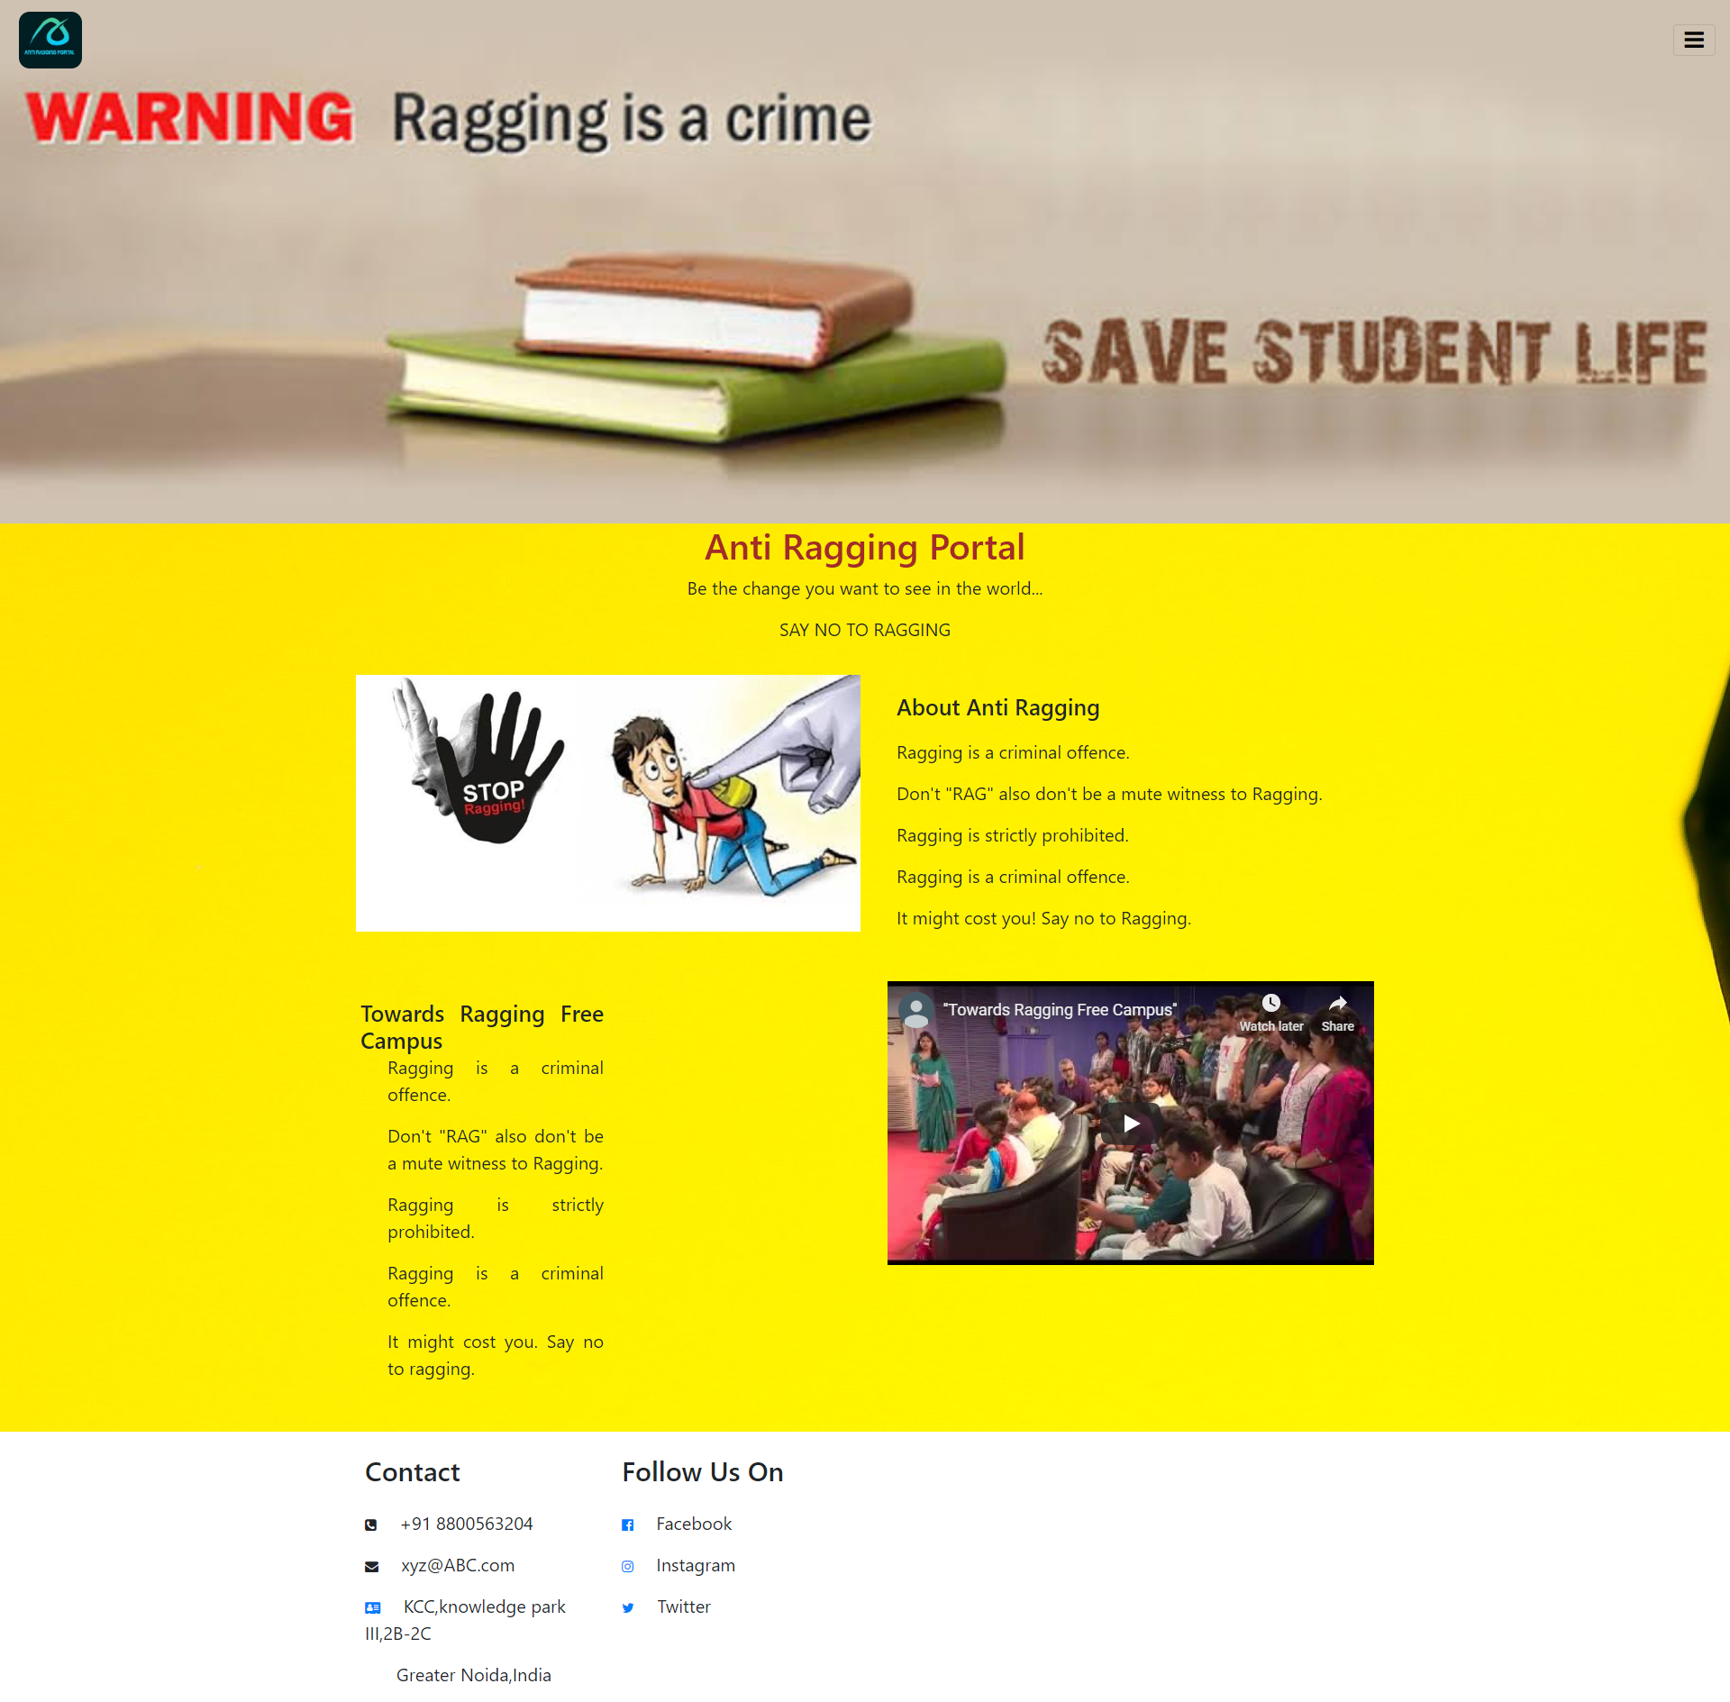

**6.5.2 The Login Page**

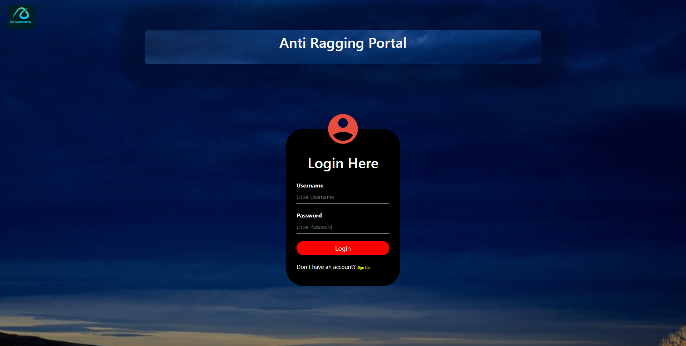

**6.5.3 The Signup Page**

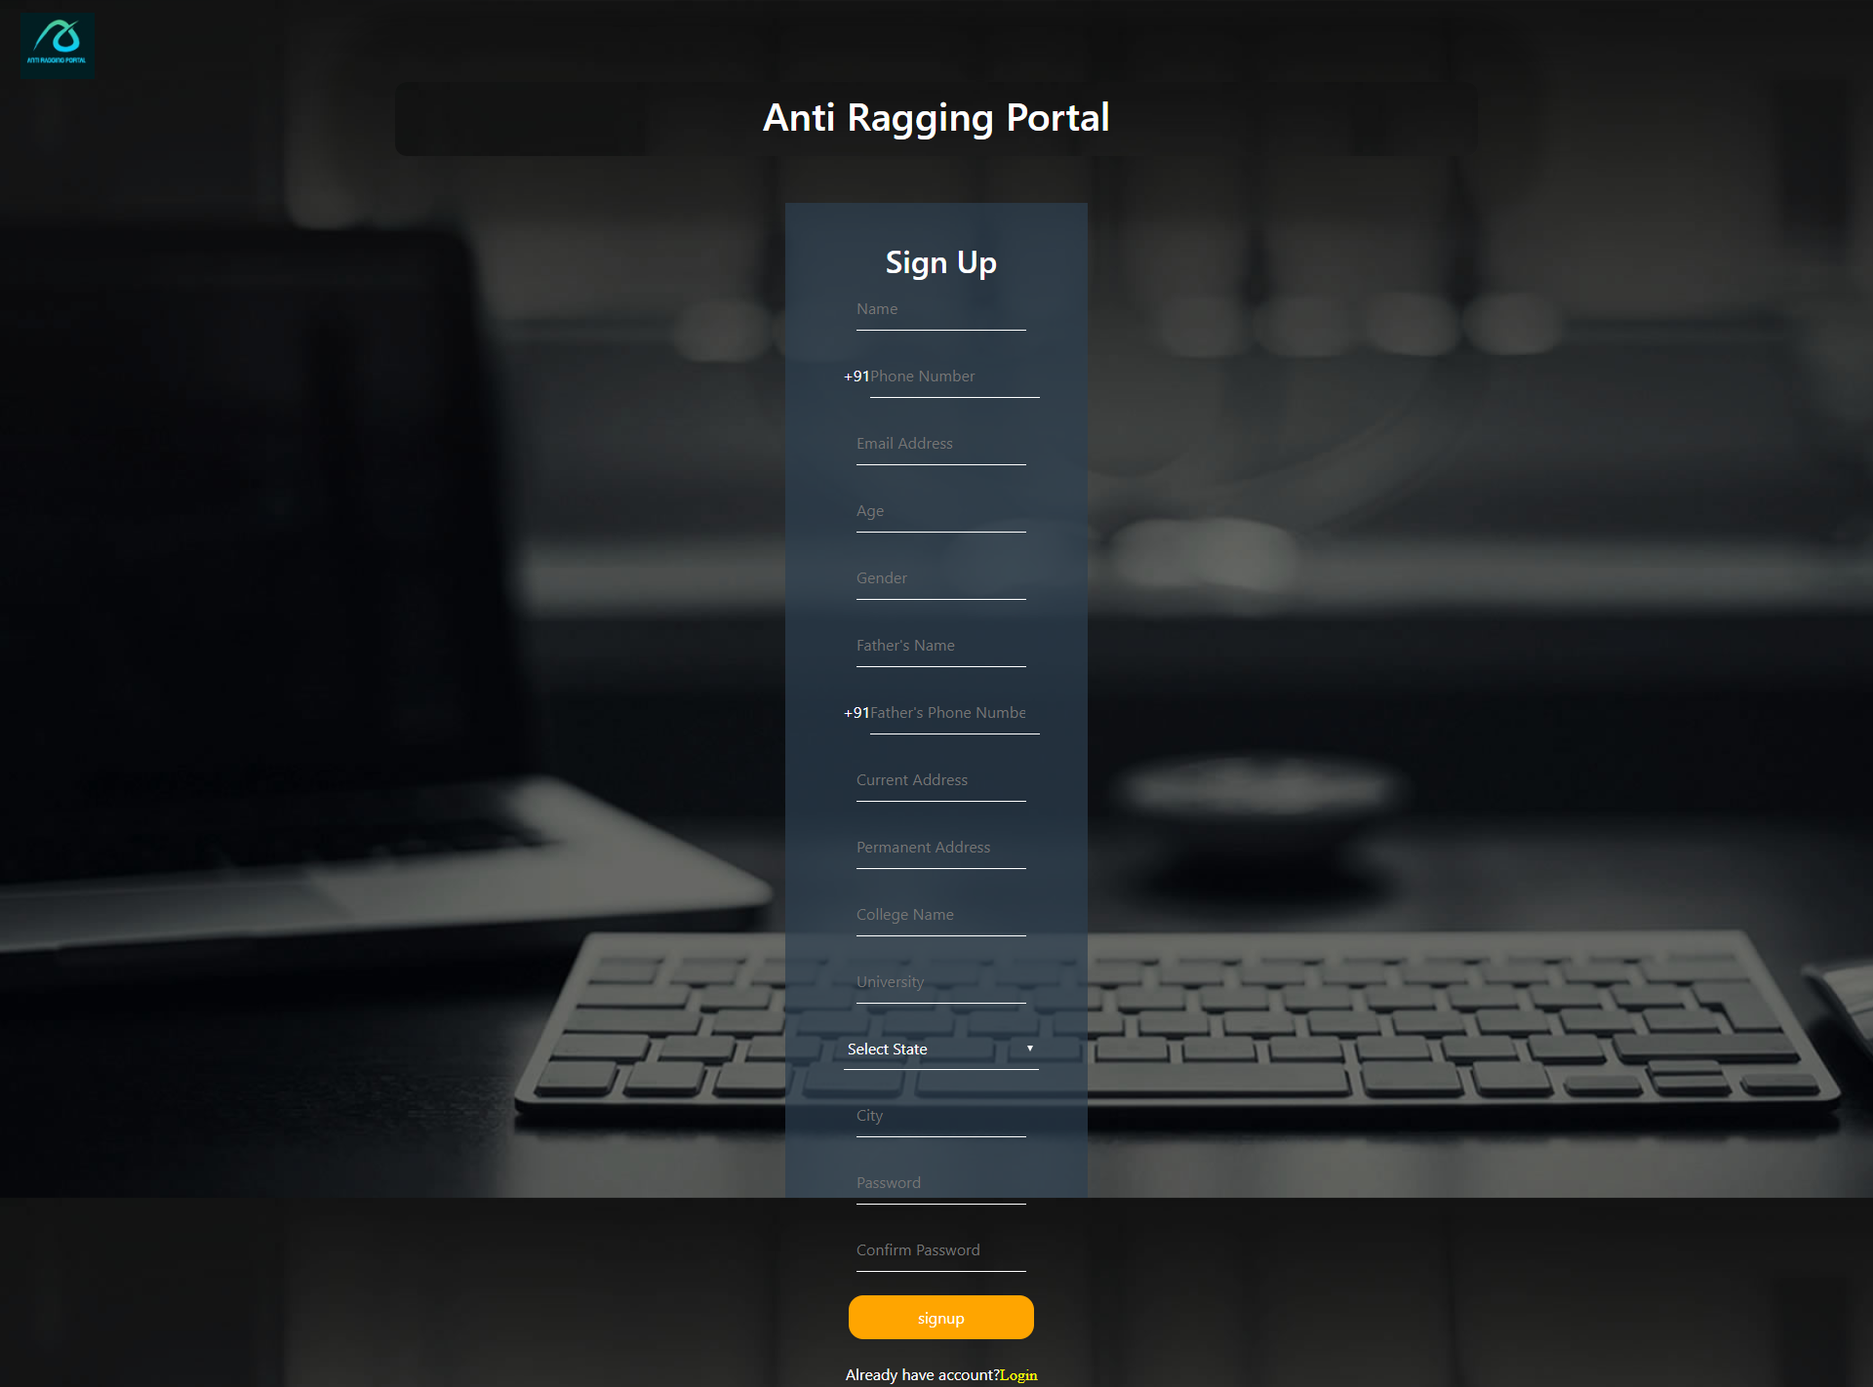

**6.5.4 User**

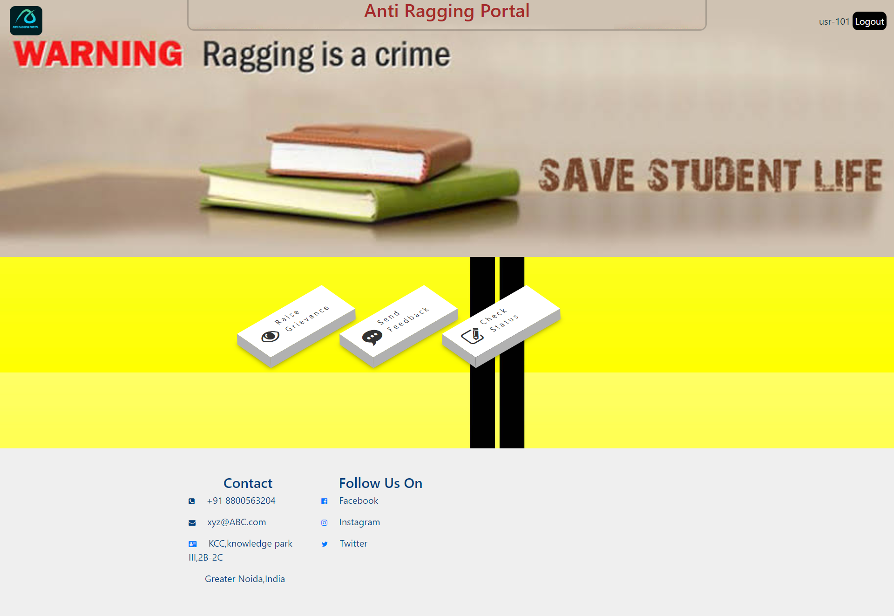

**6.5.4.1 Raise Grievance**

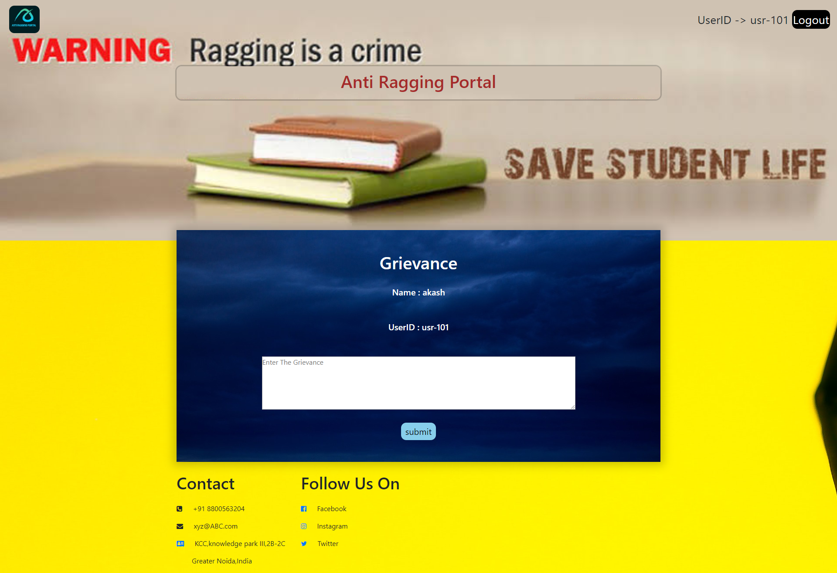

**6.5.4.2 Send Feedback**

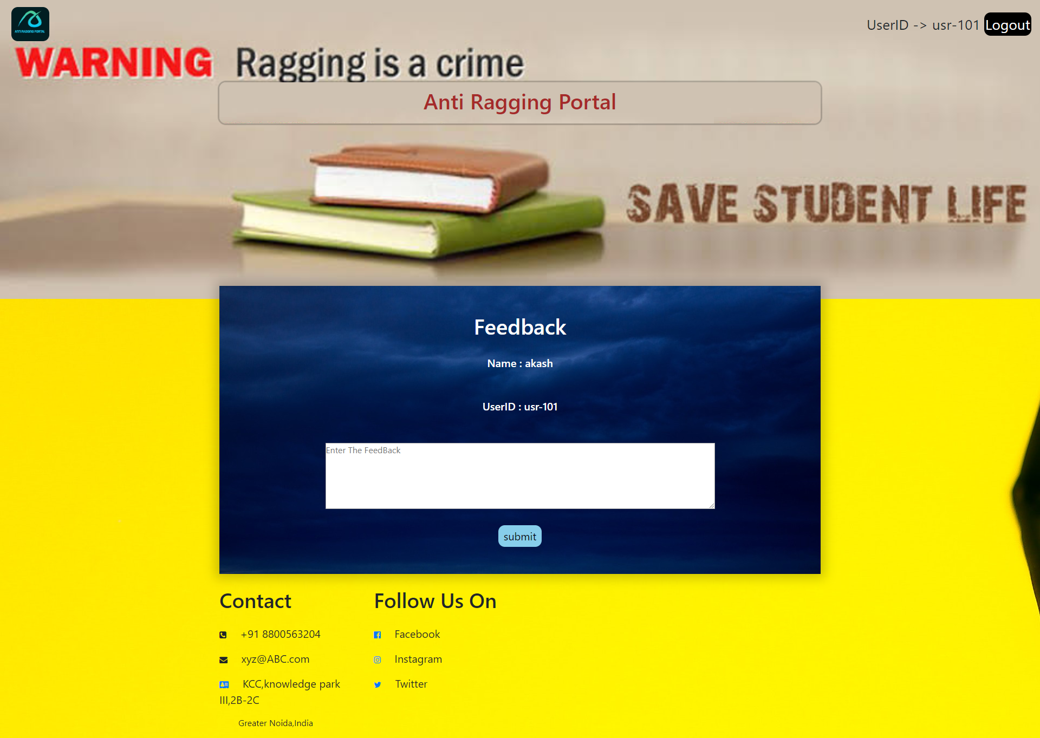

**6.5.4.3 Check Status**

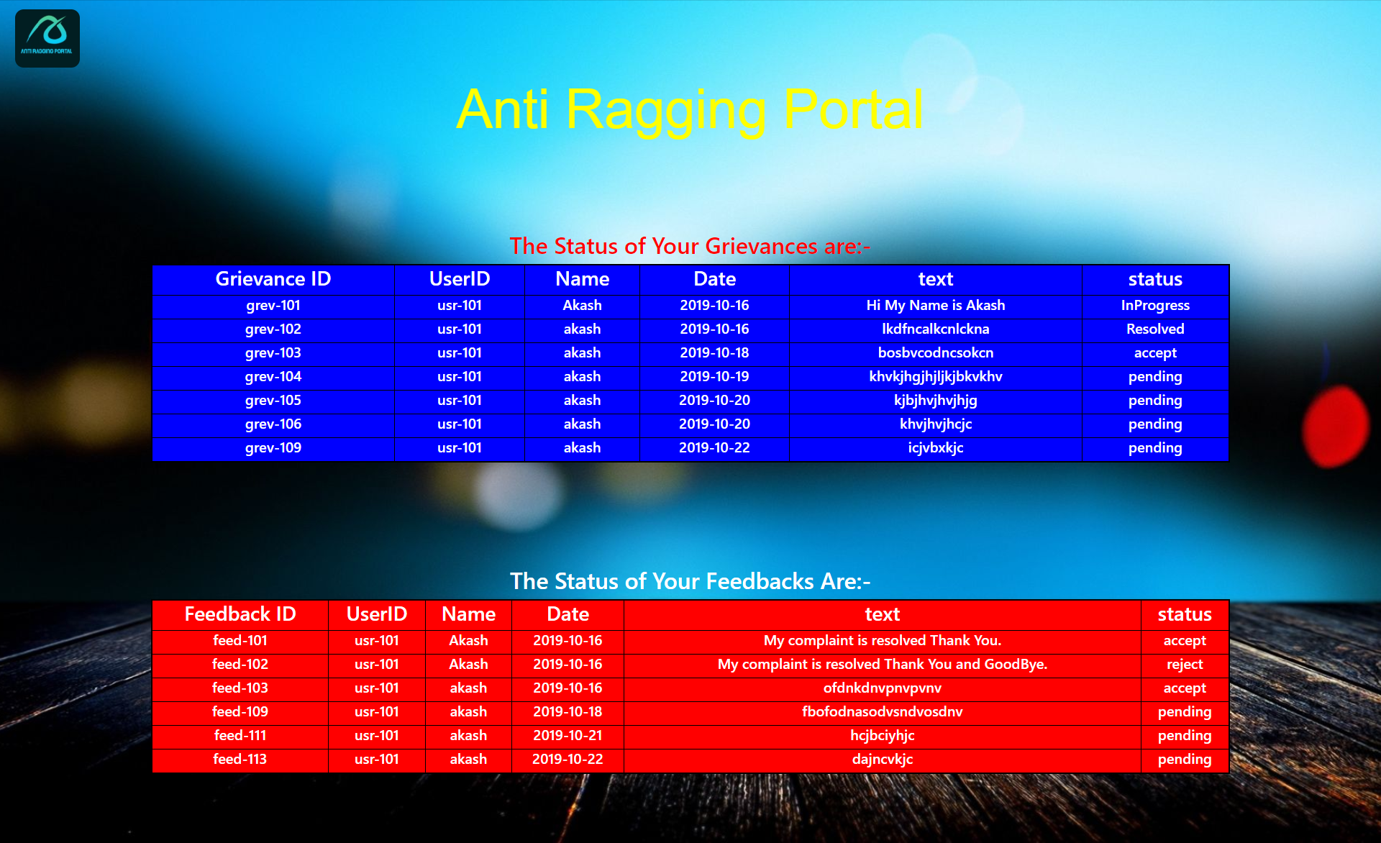

**6.5.5 Administrator**

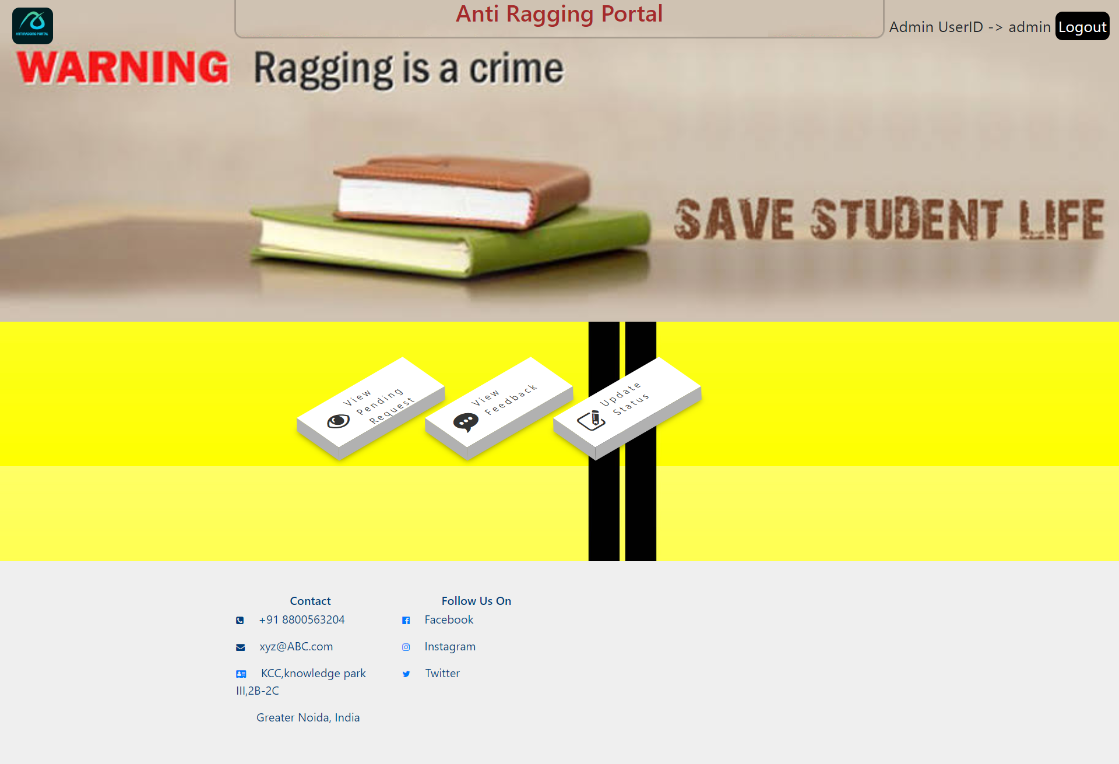

**6.5.5.1 View Pending Request**

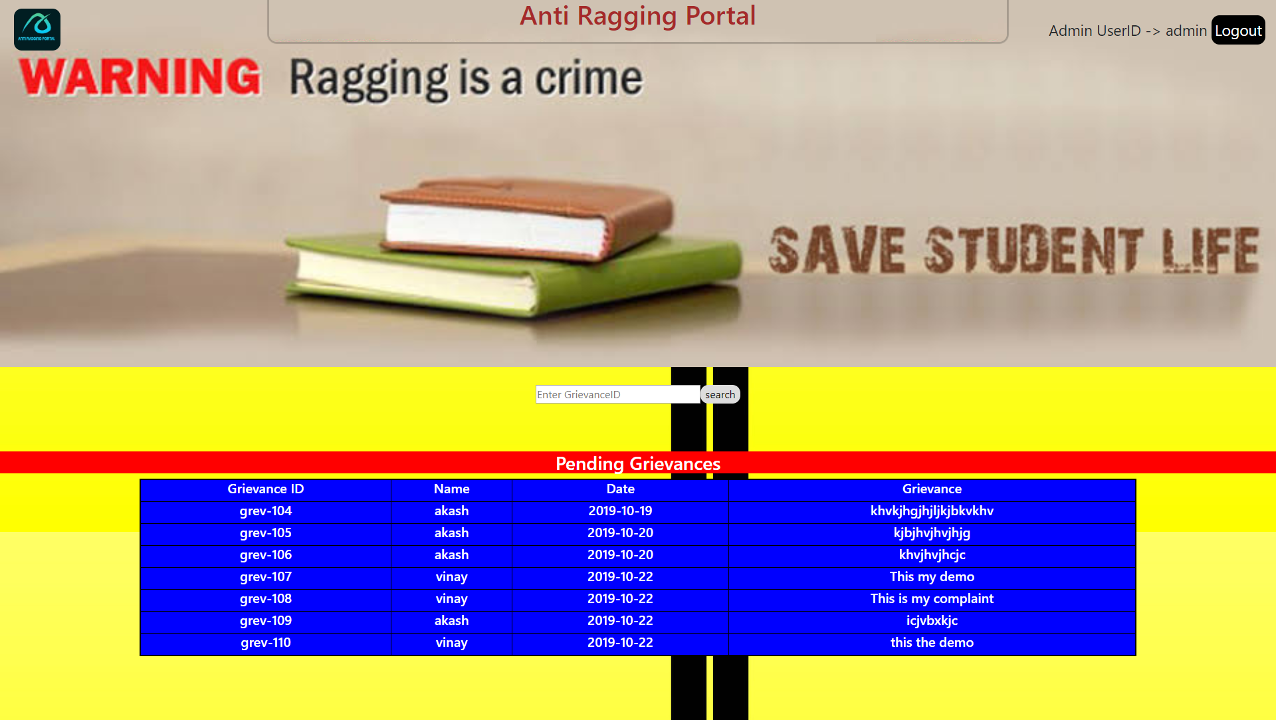

**6.5.5.2 View Feedback**

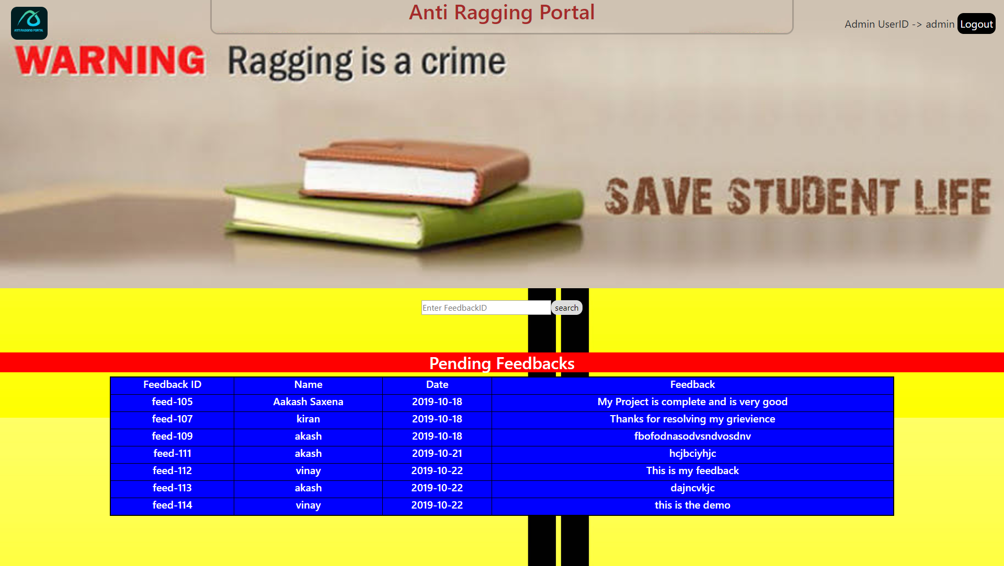

**6.5.5.3 Update Status**

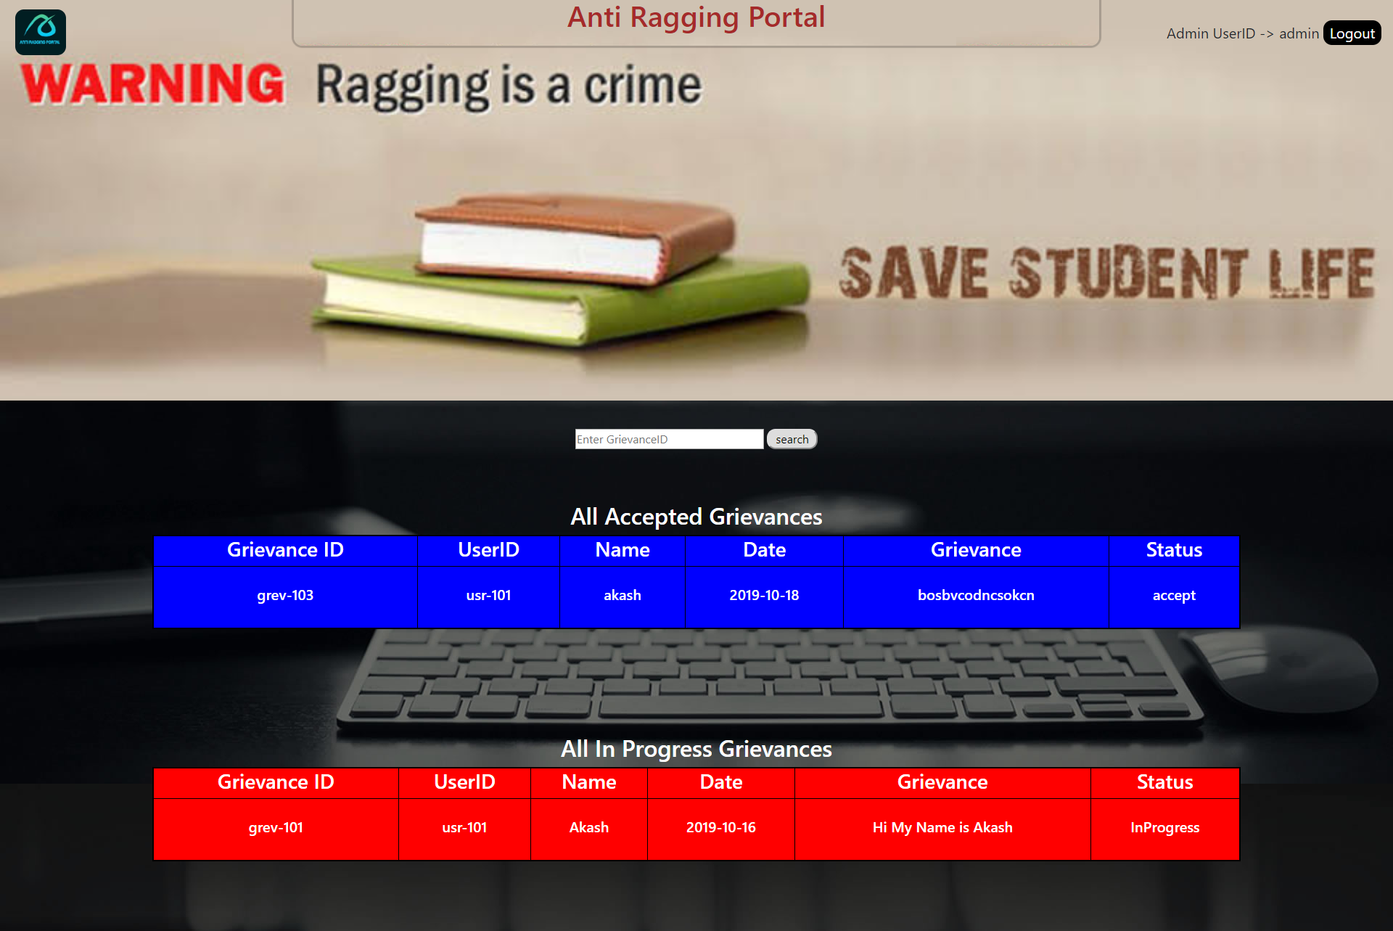

**7. Conclusion**

From the analysis of the above positive points and both advantages and the disadvantages of the existing system and the developed system, it can be concluded that the developed system performs satisfactorily as compared to the contemporary systems.

**Future Enhancement**

Since this system has been generated by using Object Oriented programming, there are many chances of reusability of the codes in other environment even in different platforms. Also its present features can be enhanced by some simple modification in the codes so as to reuse it in the changing scenario.

The website is made in all possible ways to meet the basic functional requirements of

good students.

**Bibliography**

Books:-

* 1. SQL – Ivan Bayross
  2. Java 2 The Complete Reference 5th Ed-Herbert Schildt

Websites:-

1. [www.google.com](http://www.google.com)
2. en.wikipedia.com
3. [www.msdn.library](http://www.msdn.library).